Servlets
CHAPTER

37





Objectives
- To explain how a servlet works (§37.2).
- To create/develop/run servlets (§37.3).
- To deploy servlets on application servers such as Tomcat and GlassFish (§37.3).
- To describe the servlets API (§37.4).
- To create simple servlets (§37.5).
- To create and process HTML forms (§37.6).
- To develop servlets to access databases (§37.7).
- To use hidden fields, cookies, and HttpSession to track sessions (§37.8).



37-2 Chapter 37 Servlets

Introduction

Key Point
Java Servlets is the foundation for developing Web applications using Java.
Servlets are Java programs that run on a Web server. They can be used to process client requests or produce dynamic webpages. For example, you can write servlets to generate dynamic web- pages that display stock quotes or process client registration forms and store registration data in a database. This chapter introduces the concept of Java servlets. You will learn how to develop Java servlets using NetBeans.


Note
You can develop servlets without using an IDE. However, using an IDE such as NetBeans can greatly simplify the development task. The tool can automatically create the sup- porting directories and files. We choose NetBeans because it has the best support for Java Web development. You can still use your favorite IDE or no IDE for this chapter.


Note
Servlets are the foundation of Java Web technologies. JSP, JSF, and Java Web services are based on servlets. A good understanding of servlets helps you see the big picture of Java Web technology and learn JSP, JSF, and Web services.

HTML and Common Gateway Interface

Key Point
Java servlets are Java programs that function like CGI programs. They are executed upon request from a Web browser.
Java servlets run in the Web environment. To understand Java servlets, let us review HTML and the Common Gateway Interface (CGI).

Static Web Contents
You create webpages using HTML. Your webpages are stored as files on the Web server. The files are usually stored in the /htdocs directory on Unix, as shown in Figure 37.1. A user types a URL for the file from a Web browser. The browser contacts the Web server and requests the file. The server finds the file and returns it to the browser. The browser then displays the file to the user. This works fine for static information that does not change regardless of who requests it or when it is requested. Static information is stored in files. The information in the files can be updated, but at any given time every request for the same document returns exactly the same result.

http://www.webserverhost.com/index.html

Web Browser
Web Server Host

Web Server
Host Machine File System

/htdocs/index.html

HTML Page

FIGuRE 37.1 A Web browser requests a static HTML page from a Web server.

  - HTML and Common Gateway Interface 37-3

Dynamic Web Contents and Common Gateway Interface
Not all information, however, is static in nature. Stock quotes are updated whenever a trade takes place. Election vote counts are updated constantly on Election Day. Weather reports are frequently updated. The balance in a customer’s bank account is updated whenever a transac- tion takes place. To view up-to-date information on the Web, the HTML pages for displaying this information must be generated dynamically. Dynamic Web pages are generated by Web servers. The Web server needs to run certain programs to process user requests from Web browsers in order to produce a customized response.
The Common Gateway Interface, or CGI, was proposed to generate dynamic Web content. The interface provides a standard framework for Web servers to interact with external pro- grams, known as CGI programs. As shown in Figure 37.2, the Web server receives a request from a Web browser and passes it to the CGI program. The CGI program processes the request and generates a response at runtime. CGI programs can be written in any language, but the Perl language is the most popular choice. CGI programs are typically stored in the /cgi-bin directory. Here is a pseudocode example of a CGI program for displaying a customer’s bank account balance:
      - Obtain account ID and password.
      - Verify account ID and password. If it fails, generate an HTML page to report incorrect account ID and password, and exit.
      - Retrieve account balance from the database; generate an HTML page to display the account ID and balance.

URL Example
http://www.server.com/cgi-bin/getBalance.cgi? accountId=scott&password=tiger
Web Server Host

Send a request URL

Web Server
Host Machine File System

/htdocs/index.html

HTML Page returned
Web Browser

Spawn CGI Process

Generate Response




Get CGI Code
Execute CGI Program

FIGuRE 37.2 A Web browser requests a dynamic HTML page from a Web server.

The GET and POST Methods
The two most common HTTP requests, also known as methods, are GET and POST. The Web browser issues a request using a URL or an HTML form to trigger the Web server to execute a CGI program. HTML forms will be introduced in §37.6, “HTML Forms.” When issuing a CGI request directly from a URL, the GET method is used. This URL is known as a query string. The URL query string consists of the location of the CGI program, the parameters, and their values. For example, the following URL causes the CGI program getBalance to be invoked on the server side:
http://www.webserverhost.com/cgi-bin/ getBalance.cgi?accountId=scott+smith&password=tiger

37-4 Chapter 37 Servlets
The ? symbol separates the program from the parameters. The parameter name and value are associated using the symbol. Parameter pairs are separated using the & symbol. The symbol denotes a space character. So, here accountId is scott smith.
When issuing a request from an HTML form, either a GET method or a POST method can be used. The form explicitly specifies one of these. If the GET method is used, the data in the form are appended to the request string as if it were submitted using a URL. If the POST method is used, the data in the form are packaged as part of the request file. The server program obtains the data by reading the file. The POST method is more secure than the GET method.





Check Point

Note

The GET and POST methods both send requests to the Web server. The POST method always triggers the execution of the corresponding CGI program. The GET method may not cause the CGI program to be executed, if the previous same request is cached in the Web browser. Web browsers often cache webpages so that the same request can be quickly responded to without contacting the Web server. The browser checks the request sent through the GET method as a URL query string. If the results for the exact same URL are cached on a disk, then the previous webpages for the URL may be displayed. To ensure that a new webpage is always displayed, use the POST method. For example, use a POST method if the request will actually update the database. If your request is not time sensitive, such as finding the address of a student in the database, use the GET method to speed up performance.

From CGI to Java Servlets
CGI provides a relatively simple approach for creating dynamic Web applications that accept a user request, process it on the server side, and return responses to the Web browser. But CGI is very slow when handling a large number of requests simultaneously, because the Web server spawns a process for executing each CGI program. Each process has its own runtime environ- ment that contains and runs the CGI program. It is not difficult to imagine what will happen if many CGI programs were executed simultaneously. System resource would be quickly exhausted, potentially causing the server to crash.
Several new approaches have been developed to remedy the performance problem of CGI programs. Java servlets are one successful technology for this purpose. Java servlets are Java programs that function like CGI programs. They are executed upon request from a Web browser. All servlets run inside a servlet container, also referred to as a servlet server or a servlet engine. A servlet container is a single process that runs in a Java Virtual Machine. The JVM creates a thread to handle each servlet. Java threads have much less overhead than full- blown processes. All the threads share the same memory allocated to the JVM. Since the JVM persists beyond the life cycle of a single servlet execution, servlets can share objects already created in the JVM. For example, if multiple servlets access the same database, they can share the connection object. Servlets are much more efficient than CGI.
Servlets have other benefits that are inherent in Java. As Java programs, they are object oriented, portable, and platform independent. Since you know Java, you can develop servlets immediately with the support of Java API for accessing databases and network resources.
    - What is the common gateway interface?
    - What are the differences between the GET and POST methods in an HTML form?
    - Can you submit a GET request directly from a URL? Can you submit a POST request directly from a URL?
    - What is wrong in the following URL for submitting a GET request to the servlet
FindScore on host liang at port 8084 with parameter name? http://liang:8084/findScore?name=“P Yates”
    - What are the differences between CGI and servlets?

Creating and Running Servlets

Creating and Running Servlets 37-5



An IDE such as NetBeans is an effective tool for creating Java servlet.

Key Point
To run Java servlets, you need a servlet container. Many servlet containers are available for free. Two popular ones are Tomcat (developed by Apache, www.apache.org) and Glass- Fish (developed by Sun, glassfish.dev.java.net). Both Tomcat and GlassFish are bundled and integrated with NetBeans 7 (Java EE version). When you run a servlet from NetBeans, Tomcat or GlassFish will be automatically started. You can choose to use either of them, or any other application server. GlassFish has more features than Tomcat and it takes more system resource.

Creating a Servlet
Before our introduction to the servlet API, let us look at a simple example to see how servlets work. A servlet to some extent resembles a JavaFX program. Every Java applet is a subclass of the Application class. You need to override appropriate methods in the Application class to implement the application. Every servlet is a subclass of the HttpServlet class. You need to override appropriate methods in the HttpServlet class to implement the servlet. Listing 37.1 is a servlet that generates a response in HTML using the doGet method.

Listing 37.1 FirstServlet.java
1 package chapter37;
2
- import javax.servlet.*;
- import javax.servlet.http.*;
5
- public class FirstServlet extends HttpServlet {
- /** Handle the HTTP GET method.
- * @param request servlet request
- * @param response servlet response
- */
- protected void doGet(HttpServletRequest request,
- HttpServletResponse response)
- throws ServletException, java.io.IOException {
- response.setContentType("text/html");
- java.io.PrintWriter out = response.getWriter();
- // output your page here
- out.println("<html>");
- out.println("<head>");
- out.println("<title>Servlet</title>");
- out.println("</head>");
- out.println("<body>");
- out.println("Hello, Java Servlets");
- out.println("</body>");
- out.println("</html>");
- out.close();
26 }
27 }

The doGet method (line 11) is invoked when the Web browser issues a request using the GET method. The doGet method has two parameters: request and response. request is for obtaining data from the Web browser, and response is for sending data back to the browser. Line 14 indicates that data are sent back to the browser as text/html. Line 15 obtains an instance of PrintWriter for actually outputting data to the browser.


37-6 Chapter 37 Servlets

Creating Servlets in NetBeans
NetBeans is updated frequently. The current version is 8 at the time of this writing. To create a servlet in NetBeans 8, you have to first create a Web project, as follows:
      - Choose File, New Project to display the New Project dialog box. Choose Java Web in the Categories section and Web Application in the Projects section, as shown in Figure
37.3a. Click Next to display the New Web Application dialog box, as shown in Figure
37.3b.
      - Enter liangweb in the Project Name field and c:\book in the Project Location field. Check Set as Main Project. Click Next to display the dialog box for specifying server and settings, as shown in Figure 37.4.
      - Select GlassFish Server 4.1 for server and Java EE 7 Web for Java EE Version. Click Finish to create the Web project, as shown in Figure 37.5.
Now you can create a servlet in the project, as follows:
- Right-click the liangweb node in the project pane to display a context menu. Choose
New, Servlet to display the New Servlet dialog box, as shown in Figure 37.6.

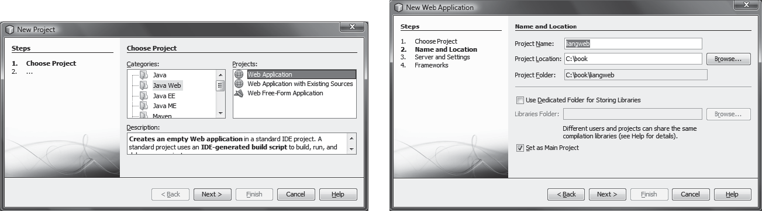
(a) (b)
FIGuRE 37.3 (a) Choose Web Application to create a Web project. (b) Specify project name and location.

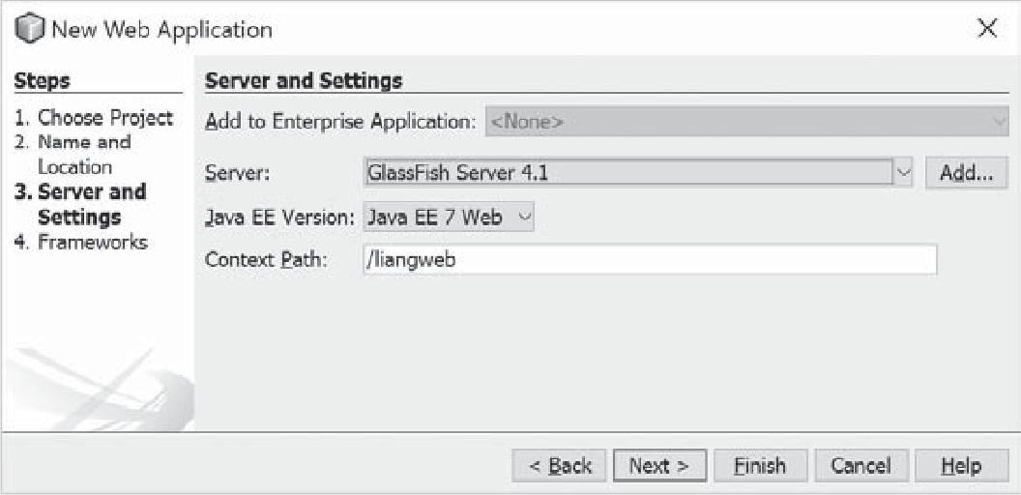
FIGuRE 37.4 Choose servers and settings.




Creating and Running Servlets 37-7
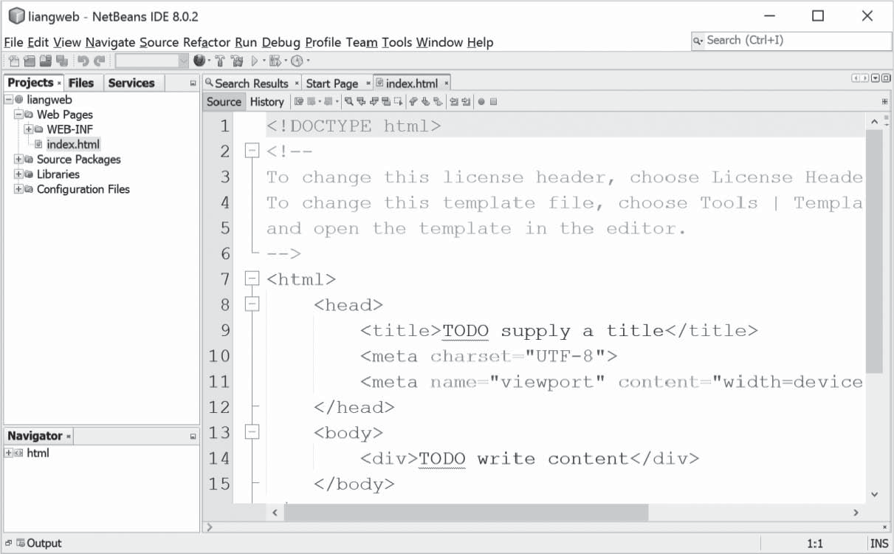
FIGuRE 37.5 A new Web project is created.

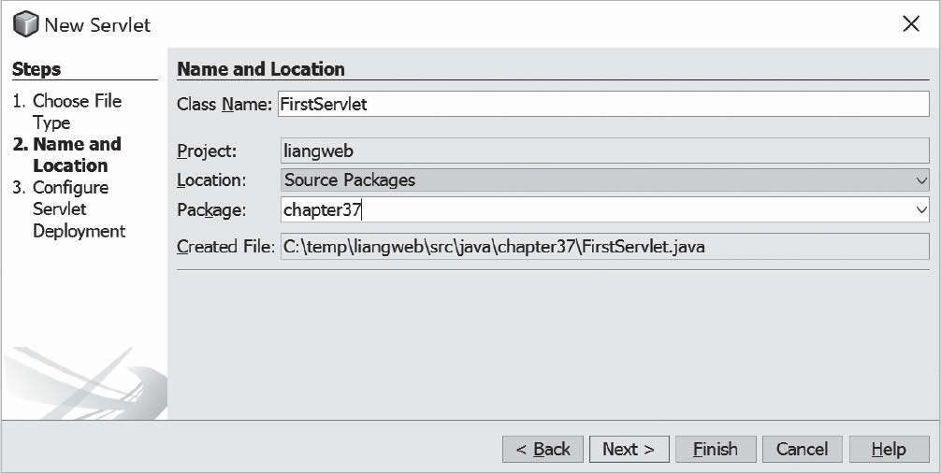
FIGuRE 37.6 You can create a servlet in the New Servlet dialog box.

- Enter FirstServlet in the Class Name field and chapter37 in the Package field and click Next to display the Configure Servlet Deployment dialog box, as shown in Figure 37.7.
- Select the checkbox to add the servlet information to web.xml and click Finish to create the servlet. A servlet template is now created in the project, as shown in Figure 37.8.


37-8 Chapter 37 Servlets
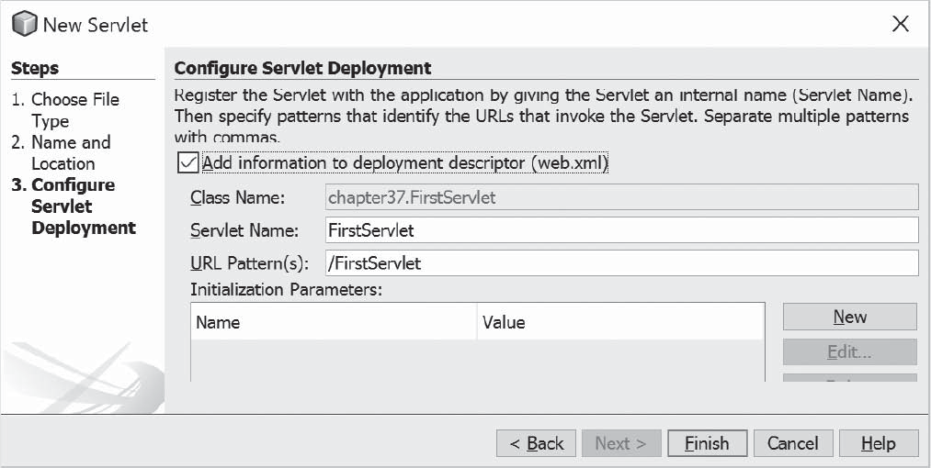
FIGuRE 37.7 You need to click the checkbox to add servlet information to web.xml.

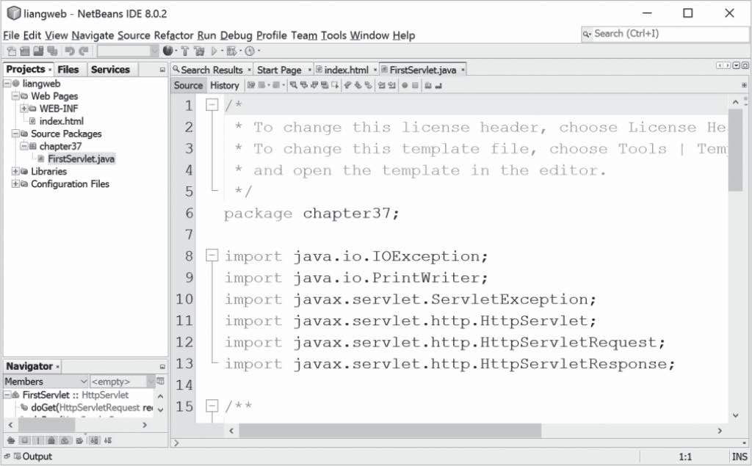

FIGuRE 37.8 A new servlet class is created in the project.

The Servlet API 37-9
- Replace the code in the content pane for the servlet using the code in Listing 37.1.
- Right-click liangweb node in the Project pane to display a context menu and choose Run to launch the Web server. In the Web browser, enter http://localhost:8084/liang- web/FirstServlet in the URL. You will now see the servlet result displayed, as shown in Figure 37.9.

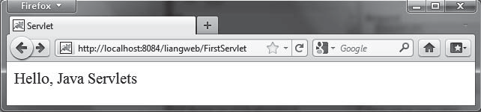
FIGuRE 37.9 Servlet result is displayed in a Web browser.


Note
If the servlet is not displayed in the browser, do the following: 1. Make sure that you have added the servlet in the xml.web file. 2. Right-click liangweb and choose Clean and Build. 3. Right-click liangweb and choose Run. Reenter http://localhost:8084/ liangweb/FirstServlet in the URL. If still not working, exit NetBeans and restart it.


Note
Depending on the server setup, you may have a port number other than 8084.

Tip
You can deploy a Web application using a Web archive file (WAR) to a Web application server (e.g., Tomcat). To create a WAR file for the liangweb project, right-click liangweb and choose Build Project. You can now locate liangweb.war in the c:\book\liang- web\dist folder. To deploy on Tomcat, simply place liangweb.war into the webapps directory. When Tomcat starts, the .war file will be automatically installed.




Note

Key Point
If you wish to use NetBeans as the development tool and Tomcat as the deployment server, please see Supplement V.E, “Tomcat Tutorial.”

    - Can you display an HTML file (e.g. c:\ test.html) by typing the complete file name in the Address field of Internet Explorer? Can you run a servlet by simply typing the servlet class file name?
    - How do you create a Web project in NetBeans?
    - How do you create a servlet in NetBeans?
    - How do you run a servlet in NetBeans?
    - When you run a servlet from NetBeans, what is the port number by default? What happens if the port number is already in use?
    - What is the .war file? How do you obtain a .war file for a Web project in NetBeans?

The Servlet API
The Servlet interface defines the methods init, service, and destroy to manag- ing the life-cylce of a serlvet.

Check Point

37-10 Chapter 37 Servlets
javax.Servlet*

javax.Servlet.http.*
HttpServletResponse
HttpServletRequest
HttpServlet
GenericServlet
ServletResponse
ServletRequest
Servlet
ServletConfig
FIGuRE 37.10 The servlet API contains interfaces and classes that you use to develop and run servlets.
You have to know the servlet API in order to understand the source code in Listing3 7.1, in FirstServlet.java. The servlet API provides the interfaces and classes that support servlets. These interfaces and classes are grouped into two packages, javax.servlet and javax. servlet.http, as shown in Figure 37.10. The javax.servlet package provides basic interfaces, and the javax.servlet.http package provides classes and interfaces derived from them, which provide specific means for servicing HTTP requests.

    - The Servlet Interface
The javax.servlet.Servlet interface defines the methods that all servlets must implement. The methods are listed below:

/** Invoked for every servlet constructed */
public void init() throws ServletException;
/** Invoked to respond to incoming requests */
public void service(ServletRequest request, ServletResponse response)
throws ServletException, IOException;
/** Invoked to release resource by the servlet */
public void destroy();

The init, service, and destroy methods are known as life-cycle methods and are called in the following sequence (see Figure 37.11):
      - The init method is called when the servlet is first created and is not called again as long as the servlet is not destroyed. This resembles an applet’s init method, which is invoked after the applet is created and is not invoked again as long as the applet is not destroyed.

JVM loads the servlet class

Creates the servlet using its constructor

Invokes the init method

Invokes the service method
Invokes destroy() after a timeout period has passed or the Web server is being stopped

Loaded
Created
Initialized
Served Destroyed

Servlet is invoked for the first time

The same servlet is invoked again, bypassing the Loaded, Created, and Initialized states, as long as it has not been destroyed
Invokes the service method



FIGuRE 37.11 The JVM uses the init, service, and destroy methods to control the servlet.



  - The Servlet API 37-11
      - The service method is invoked each time the server receives a request for the servlet. The server spawns a new thread and invokes service.
      - The destroy method is invoked after a timeout period has passed or as the Web server is terminated. This method releases resources for the servlet.

    - The GenericServlet Class, ServletConfig Interface, and HttpServlet Class
The javax.servlet.GenericServlet class defines a generic, protocol-independent servlet. It implements javax.servlet.Servlet and javax.servlet.ServletConfig. ServletConfig is an interface that defines four methods (getInitParameter, getInit- ParameterNames, getServletContext, and getServletName) for obtaining information from a Web server during initialization. All the methods in Servlet and ServletConfig are implemented in GenericServlet except service. Therefore, GenericServlet is an abstract class.
The javax.servlet.http.HttpServlet class defines a servlet for the HTTP protocol. It extends GenericServlet and implements the service method. The service method is implemented as a dispatcher of HTTP requests. The HTTP requests are processed in the following methods:
- doGet is invoked to respond to a GET request.
- doPost is invoked to respond to a POST request.
- doDelete is invoked to respond to a DELETE request. Such a request is normally used to delete a file on the server.
- doPut is invoked to respond to a PUT request. Such a request is normally used to send a file to the server.
- doOptions is invoked to respond to an OPTIONS request. This returns information about the server, such as which HTTP methods it supports.
- doTrace is invoked to respond to a TRACE request. Such a request is normally used for debugging. This method returns an HTML page that contains appropriate trace information.
All these methods use the following signature:

protected void doXxx(HttpServletRequest req, HttpServletResponse resp)
throws ServletException, java.io.IOException

The HttpServlet class provides default implementation for these methods. You need to override doGet, doPost, doDelete, and doPut if you want the servlet to process a GET, POST, DELETE, or PUT request. By default, nothing will be done. Normally, you should not override the doOptions method unless the servlet implements new HTTP methods beyond those implemented by HTTP 1.1. Nor is there any need to override the doTrace method.


Note
GET and POST requests are often used, whereas DELETE, PUT, OPTIONS, and TRACE are not. For more information about these requests, please refer to the HTTP 1.1 specifica- tion from www.cis.ohio-state.edu/htbin/rfc/rfc2068.html.


Note
Although the methods in HttpServlet are all nonabstract, HttpServlet is defined as an abstract class. Thus you cannot create a servlet directly from HttpServlet. Instead you have to define your servlet by extending HttpServlet.

37-12 Chapter 37 Servlets
The relationship of these interfaces and classes is shown in Figure 37.12.
«interface»
javax.servlet.ServletConfig
javax.servlet.GenericServlet
+init(config: ServletConfig): void
+service(req: ServletRequest, resp: ServletResponse): void
+destroy(): void
+getServletInfo(): String
«interface»
javax.servlet.Servlet
+getInitParameter(name: String): String
+getInitParameterNames(): Enumeration
+getServletContext(): ServletContext
+getServletName(): String
javax.servlet.http.HttpServlet
+doGet(req: HttpServletRequest, resp: HttpServletResponse): void
+doPost(req: HttpServletRequest, resp: HttpServletResponse): void
+doDelete(req: HttpServletRequest, resp: HttpServletResponse): void
+doPut(req: HttpServletRequest, resp: HttpServletResponse): void
+doOptions(req: HttpServletRequest, resp: HttpServletResponse): void
+doTrace(req: HttpServletRequest, resp: HttpServletResponse): void

FIGuRE 37.12 HttpServlet inherits abstract class GenericServlet, which implements interfaces Servlet and
ServletConfig.



Check Point
    - The ServletRequest Interface
and HttpServletRequest Interface
Every doXxx method in the HttpServlet class has a parameter of the HttpServletRequest type, which is an object that contains HTTP request information, including parameter name and values, attributes, and an input stream. HttpServletRequest is a subinterface of Servlet- Request. ServletRequest defines a more general interface to provide information for all kinds of clients. The frequently used methods in these two interfaces are shown in Figure 37.13.
    - The ServletResponse Interface
and HttpServletResponse Interface
Every doXxx method in the HttpServlet class has a parameter of the HttpServlet- Response type, which is an object that assists a servlet in sending a response to the client. HttpServletResponse is a subinterface of ServletResponse. ServletResponse defines a more general interface for sending output to the client.
The frequently used methods in these two interfaces are shown in Figure 37.14.
    - Describe the life cycle of a servlet.
    - Suppose you started the Web server, ran the following servlet twice by issuing an appropriate URL from the Web browser, and finally stopped Tomcat. What was displayed on the console when the servlet was first invoked? What was displayed on the console when the servlet was invoked for the second time? What was displayed on the console when Tomcat was shut down?
import javax.servlet.*; import javax.servlet.http.*; import java.io.*;
public class Test extends HttpServlet {
public Test() { System.out.println("Constructor called");


}

/** Initialize variables */
public void init() throws ServletException {



37.4 The Servlet API 37-13

System.out.println("init called");
}

/** Process the HTTP Get request */
public void doGet(HttpServletRequest request, HttpServletResponse response)
throws ServletException, IOException { System.out.println("doGet called");
}

/** Clean up resources */
public void destroy() { System.out.println("destroy called");
}
}
+getRemoteAddr(): String
+getRemoteHost(): String
+getParamter(name: String): String
+getParameterValues(): String[]
«interface»
javax.servlet.ServletRequest

Returns the value of a request parameter as a String, or null if the parameter does not exist. Request parameters are extra information sent with the request. For HTTP servlets, parameters are contained in the query string or posted from data. Only use this method when you are sure that the parameter has only one value. If it has more than one value, use getParameterValues.
Returns the Internet Protocol (IP) address of the client that sent the request.
Returns the fully qualified name of the client that sent the request, or the IP address of the client if the name cannot be determined.


«interface»
javax.servlet.http.HttpServletRequest
+getHeader(name: String): String  +getMethod(): String  +getQueryString(): String  +getCookies(): javax.servlet.http.Cookies[]  +getSession(create: boolean): HttpSession |  | Returns the value of the specified request header as a String. If the request did not include a header of the specified name, this method returns null. Since the header name is case- insensitive, you can use this method with any request header.  Returns the name of the HTTP method with which this request was made; for example, GET, POST, DELETE, PUT, OPTIONS, or TRACE.  Returns the query string that is contained in the request URL after the path. This method returns null if the URL does not have a query string.  Returns an array containing all of the Cookie objects the client sent with the request. This method returns null if no cookies were sent. Using cookies is introduced in Section 37.8.2, “Session Tracking Using Cookies.”  getSession(true) returns the current session associated with this request. If the request does not have a session, it creates one. getSession(false) returns the current session associated with the request. If the request does not have a session, it returns null. The getSession method is used in session tracking, which is introduced in Section 37.8.3, “Session Tracking Using the Servlet API.”

FIGuRE 37.13 HttpServletRequest is a subinterface of ServletRequest.

Returns a PrintWriter object that can send character text to the client.
+getWriter(): java.io.PrintWriter
+setContentType(type: String): void
«interface»
javax.servlet.ServletResponse
Sets the content type of the response being sent to the client before writing response to the client. When you are writing HTML to the client, the type should be set to “text/html.” For plain text, use “text/plain.” For sending a gif image to the browser, use “image/gif.”
+addCookie(Cookie cookie): void
«interface»
javax.servlet.http.HttpServletResponse

Adds the specified cookie to the response. This method can be called multiple times to set more than one cookie.
FIGuRE 37.14 HttpServletResponse is a subinterface of ServletResponse.



37-14 Chapter 37 Servlets

Creating Servlets

Key Point
You can define a servlet class by extending the HttpServlet class and implement the
doGet and doPost methods.
Servlets are the opposite of Java applets. Java applets run from a Web browser on the client side. To write Java programs, you define classes. To write a Java applet, you define a class that extends the Applet class. The Web browser runs and controls the execution of the applet through the methods defined in the Applet class. Similarly, to write a Java servlet, you define a class that extends the HttpServlet class. The servlet container runs and controls the execu- tion of the servlet through the methods defined in the HttpServlet class. Like a Java applet, a servlet does not have a main method. A servlet depends on the servlet engine to call the methods. Every servlet has a structure like the one shown below:

package chapter37;

import javax.servlet.*; import javax.servlet.http.*; import java.io.*;

public class MyServlet extends HttpServlet {
/** Called by the servlet engine to initialize servlet */
public void init() throws ServletException {
...
}

/** Process the HTTP Get request */
public void doGet(HttpServletRequest request, HttpServletResponse response) throws ServletException, IOException {
...
}

/** Process the HTTP Post request */
public void doPost(HttpServletRequest request, HttpServletResponse response) throws ServletException, IOException {
...
}

/** Called by the servlet engine to release resource */
public void destroy() {
...
}

// Other methods if necessary
}
The servlet engine controls the servlets using init, doGet, doPost, destroy, and other meth- ods. By default, the doGet and doPost methods do nothing. To handle a GET request, you need to override the doGet method; to handle a POST request, you need to override the doPost method.
Listing 37.2 gives a simple Java servlet that generates a dynamic webpage for displaying the current time, as shown in Figure 37.15.
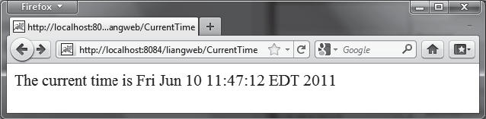
FIGuRE 37.15 Servlet CurrentTime displays the current time.



  - HTML Forms 37-15
Listing 37.2 CurrentTime.java
1 package chapter37;
2
- import javax.servlet.*;
- import javax.servlet.http.*;
- import java.io.*;
6
- public class CurrentTime extends HttpServlet {
- /** Process the HTTP Get request */
- public void doGet(HttpServletRequest request, HttpServletResponse
- response) throws ServletException, IOException {
- response.setContentType("text/html");
- PrintWriter out = response.getWriter();
- out.println("<p>The current time is " + new java.util.Date());
- out.close(); // Close stream
15 }
16 }
The HttpServlet class has a doGet method. The doGet method is invoked when the browser issues a request to the servlet using the GET method. Your servlet class should override the doGet method to respond to the GET request. In this case, you write the code to display the current time. Servlets return responses to the browser through an HttpServletResponse object.
Since the setContentType("text/html") method sets the MIME type to “text/html,” the browser will display the response in HTML. The getWriter method returns a PrintWriter object for sending HTML back to the client.


Note
The URL query string uses the GET method to issue a request to the servlet. The current time may not be current if the webpage for displaying the current time is cached. To ensure that a new current time is displayed, refresh the page in the browser. In the next example, you will write a new servlet that uses the POST method to obtain the current time.

HTML Forms

Key Point
HTML forms are used to collect and submit data from a client to a Web server.
HTML forms enable you to submit data to the Web server in a convenient form. As shown in Figure 37.16, the form can contain text fields, text area, check boxes, combo boxes, lists, radio buttons, and buttons.
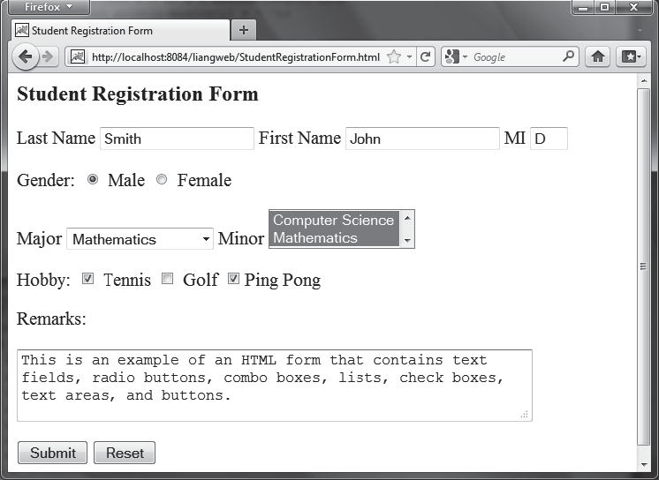
FIGuRE 37.16 An HTML form may contain text fields, radio buttons, combo boxes, lists, check boxes, text areas, and buttons.



37-16 Chapter 37 Servlets
The HTML code for creating the form in Figure 37.16 is given in Listing 37.3. (If you are unfamiliar with HTML, please see Supplement V.A, “HTML and XHTML Tutorial.”)

Listing 37.3 StudentRegistrationForm.html
- <!--An HTML Form Demo -->
- <html>
- <head>
- <title>Student Registration Form</title>
- </head>
- <body>
- <h3>Student Registration Form</h3> 8
- <form action = "GetParameters"
- method = "get">
- <!-- Name text fields -->
- <p><label>Last Name</label>
- <input type = "text" name = "lastName" size = "20" />
- <label>First Name</label>
- <input type = "text" name = "firstName" size = "20" />
- <label>MI</label>
- <input type = "text" name = "mi" size = "1" /></p> 18
- <!-- Gender radio buttons -->
- <p><label>Gender:</label>
- <input type = "radio" name = "gender" value = "M" checked />
- Male
- <input type = "radio" name = "gender" value = "F" /> Female</p> 24
- <!-- Major combo box -->
- <p><label>Major</label>
- <select name = "major" size = "1">
- <option value = "CS">Computer Science</option>
- <option value = "Math">Mathematics</option>
- <option>English</option>
- <option>Chinese</option>
- </select>
33
- <!-- Minor list -->
- <label>Minor</label>
- <select name = "minor" size = "2" multiple>
- <option>Computer Science</option>
- <option>Mathematics</option>
- <option>English</option>
- <option>Chinese</option>
- </select></p>
42
- <!-- Hobby check boxes -->
- <p><label>Hobby:</label>
- <input type = "checkbox" name = "tennis" /> Tennis
- <input type = "checkbox" name = "golf" /> Golf
- <input type = "checkbox" name = "pingPong" checked />Ping Pong
48 </p>
49
- <!-- Remark text area -->
- <p>Remarks:</p>
- <p><textarea name = "remarks" rows = "3" cols = "56">
- </textarea></p>
54




 |  | 37.6 | HTML Forms 37-17
55 | <!-- Submit and Reset buttons -->
56 | <p><input type = "submit" value = "Submit" />
57 | <input type = "reset" value = "Reset" /></p>
58 | </form>
59 | </body>
60 | </html>

The following HTML tags are used to construct HTML forms:
- <form> . . . </form> defines a form body. The attributes for the <form> tag are action and method. The action attribute specifies the server program to be exe- cuted on the Web server when the form is submitted. The method attribute is either get or post.
- <label> . . . </label> simply defines a label.
- <input> defines an input field. The attributes for this tag are type, name, value, checked, size, and maxlength. The type attribute specifies the input type. Possible types are text for a one-line text field, radio for a radio button, and checkbox for a check box. The name attribute gives a formal name for the attribute. This name attribute is used by the servlet program to retrieve its associated value. The names of the radio buttons in a group must be identical. The value attribute specifies a default value for a text field and text area. The checked attribute indicates whether a radio button or a check box is initially checked. The size attribute specifies the size of a text field, and the maxlength attribute specifies the maximum length of a text field.
- <select> . . . </select> defines a combo box or a list. The attributes for this tag are name, size, and multiple. The size attribute specifies the number of rows visible in the list. The multiple attribute specifies that multiple values can be selected from a list. Set size to 1 and do not use a multiple for a combo box.
- <option> . . . </option> defines a selection list within a <select> . . .
</select> tag. This tag may be used with the value attribute to specify a value for the selected option (e.g., <option value = "CS">Computer Science). If no value is specified, the selected option is the value.
- <textarea> . . . </textarea> defines a text area. The attributes are name, rows, and cols. The rows and cols attributes specify the number of rows and columns in a text area.


Note
You can create the HTML file from NetBeans. Right-click liangweb and choose New, HTML, to display the New HTML File dialog box. Enter StudentRegistrationForm as the file name and click Finish to create the file.

Obtaining Parameter Values from HTML Forms
To demonstrate how to obtain parameter values from an HTML form, Listing 37.4 creates a servlet to obtain all the parameter values from the preceding student registration form in Figure 37.16 and display their values, as shown in Figure 37.17.

Listing 37.4 GetParameters.java
1 package chapter37;
2
3 import javax.servlet.*;



37-18 Chapter 37 Servlets

4 | import | javax.servlet.http.*;
5 | import | java.io.*;
6
7 | public | class GetParameters extends HttpServlet {
- /** Process the HTTP Post request */
- public void doGet(HttpServletRequest request, HttpServletResponse
- response) throws ServletException, IOException {
- response.setContentType("text/html");
- PrintWriter out = response.getWriter(); 13
- // Obtain parameters from the client
- String lastName = request.getParameter("lastName");
- String firstName = request.getParameter("firstName");
- String mi = request.getParameter("mi");
- String gender = request.getParameter("gender");
- String major = request.getParameter("major");
- String[] minors = request.getParameterValues("minor");
- String tennis = request.getParameter("tennis");
- String golf = request.getParameter("golf");
- String pingPong = request.getParameter("pingPong");
- String remarks = request.getParameter("remarks"); 25
26 out.println("Last Name: <b>" + lastName + "</b> First Name: <b>"
27 + firstName + "</b> MI: <b>" + mi + "</b><br>");
- out.println("Gender: <b>" + gender + "</b><br>");
- out.println("Major: <b>" + major + "</b> Minor: <b>"); 30
- if (minors != null)
- for (int i = 0; i < minors.length; i++)
- out.println(minors[i] + " "); 34
- out.println("</b><br> Tennis: <b>" + tennis + "</b> Golf: <b>" +
- golf + "</b> PingPong: <b>" + pingPong + "</b><br>");
- out.println("Remarks: <b>" + remarks + "</b>");
- out.close(); // Close stream
39 }
40 }
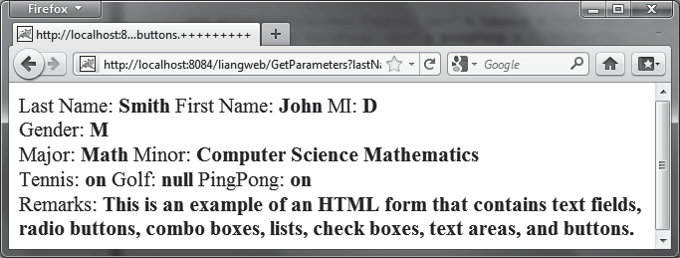
FIGuRE 37.17 The servlet displays the parameter values entered in Figure 37.16.

The HTML form is already created in StudentRegistrationForm.html and displayed in Figure 37.16. Since the action for the form is GetParameters, clicking the Submit button invokes the GetParameters servlet.
Each GUI component in the form has a name attribute. The servlet uses the name attribute in the getParameter(attributeName) method to obtain the parameter value as a string. In case of a list with multiple values, use the getParameterValues(attributeName) method to return the parameter values in an array of strings (line 20).


37.6 HTML Forms 37-19
You may optionally specify the value attribute in a text field, text area, combo box, list, check box, or radio button in an HTML form. For text field and text area, the value attribute specifies a default value to be displayed in the text field and text area. The user can type in new values to replace it. For combo box, list, check box, and radio button, the value attribute specifies the parameter value to be returned from the getParameter and getParameter- Values methods. If the value attribute is not specified for a combo box or a list, it returns the selected string from the combo box or the list. If the value attribute is not specified for a radio button or a check box, it returns string on for a checked radio button or a checked check box, and returns null for an unchecked check box.


Note
If an attribute does not exist, the getParameter(attributeName) method returns null. If an empty value of the parameter is passed to the servlet, the getParameter(attributeName) method returns a string with an empty value. In this case, the length of the string is 0.

Obtaining Current Time Based on Locale and Time Zone
This example creates a servlet that processes the GET and POST requests. The GET request generates a form that contains a combo box for locale and a combo box for time zone, as shown in Figure 37.18a. The user can choose a locale and a time zone from this form to submit a POST request to obtain the current time based on the locale and time zone, as shown in Figure 37.18b.

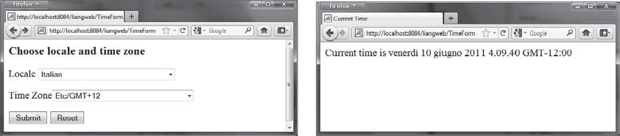
(a) (b)
FIGuRE 37.18 The GET method in the TimeForm servlet displays a form in (a), and the POST method in the TimeForm servlet displays the time based on locale and time zone in (b).

Listing 37.5 gives the servlet.
Listing 37.5 TimeForm.java
1 package chapter37;
2
- import javax.servlet.*;
- import javax.servlet.http.*;
- import java.io.*;
- import java.util.*;
- import java.text.*;
8
- public class TimeForm extends HttpServlet {
- private static final String CONTENT_TYPE = "text/html";
- private Locale[] allLocale = Locale.getAvailableLocales();
- private String[] allTimeZone = TimeZone.getAvailableIDs(); 13
- /** Process the HTTP Get request */
- public void doGet(HttpServletRequest request, HttpServletResponse


37-20 Chapter 37 Servlets

- response) throws ServletException, IOException {
- response.setContentType(CONTENT_TYPE);
- PrintWriter out = response.getWriter();
- out.println("<h3>Choose locale and time zone</h3>");
- out.println("<form method=\"post\" action=" +
- "TimeForm>");
- out.println("Locale <select size=\"1\" name=\"locale\">"); 23
- // Fill in all locales
- for (int i = 0; i < allLocale.length; i++) {
- out.println("<option value=\"" + i +"\">" +
- allLocale[i].getDisplayName() + "</option>");

28 |  | }
29 |  | out.println("</select>");
30
31 |  | // Fill in all time zones
32 |  | out.println("<p>Time Zone<select size=\"1\" name=\"timezone\">");
33 |  | for (int i = 0; i < allTimeZone.length; i++) {
34 |  | out.println("<option value=\"" + allTimeZone[i] +"\">" +
35 |  | allTimeZone[i] + "</option>");
36 |  | }
37 |  | out.println("</select>");
38
39 |  | out.println("<p><input type=\"submit\" value=\"Submit\" >");
40 |  | out.println("<input type=\"reset\" value=\"Reset\"></p>");
41 |  | out.println("</form>");
42 |  | out.close(); // Close stream
43 |  | }
44
45 |  | /** Process the HTTP Post request */
46 |  | public void doPost(HttpServletRequest request, HttpServletResponse
47 |  | response) throws ServletException, IOException {
48 |  | response.setContentType(CONTENT_TYPE);
49 |  | PrintWriter out = response.getWriter();
50 |  | out.println("<html>");
51 |  | int localeIndex = Integer.parseInt(
52 |  | request.getParameter("locale"));
53 |  | String timeZoneID = request.getParameter("timezone");
54 |  | out.println("<head><title>Current Time</title></head>");
55 |  | out.println("<body>");
56 |  | Calendar calendar =
57 |  | new GregorianCalendar(allLocale[localeIndex]);
58 |  | TimeZone timeZone = TimeZone.getTimeZone(timeZoneID);
59 |  | DateFormat dateFormat = DateFormat.getDateTimeInstance(
60 |  | DateFormat.FULL, DateFormat.FULL, allLocale[localeIndex]);
61 |  | dateFormat.setTimeZone(timeZone);
62 |  | out.println("Current time is " +
63 |  | dateFormat.format(calendar.getTime()) + "</p>");
64 |  | out.println("</body></html>");
65 |  | out.close(); // Close stream
66 |  | }
67 | }

When you run this servlet, the servlet TimeForm’s doGet method is invoked to generate the time form dynamically. The method of the form is POST, and the action invokes the same servlet, TimeForm. When the form is submitted to the server, the doPost method is invoked to process the request.
The variables allLocale and allTimeZone (lines 11–12), respectively, hold all the avail- able locales and time zone IDs. The names of the locales are displayed in the locale list. The values for the locales are the indexes of the locales in the array allLocale. The time zone IDs




Database Programming in Servlets 37-21
are strings. They are displayed in the time zone list. They are also the values for the list. The indexes of the locale and the time zone are passed to the servlet as parameters. The doPost method obtains the values of the parameters (lines 51–53) and finds the current time based on the locale and time zone.


Note
If you choose an Asian locale (e.g., Chinese, Korean, or Japanese), the time will not be displayed properly, because the default character encoding is UTF-8. To fix this problem, insert the following statement in line 48 to set an international character encoding:
response.setCharacterEncoding("GB18030");
For information on encoding, see Section 36.6.6, “Character Encoding.”

37.7 Database Programming in Servlets

Key Point
Servlets can access and manipulate databases using JDBC.
Many dynamic Web applications use databases to store and manage data. Servlets can connect to any relational database via JDBC. In Chapter 34, Java Database Programming, you learned how to create Java programs to access and manipulate relational databases via JDBC. Con- necting a servlet to a database is no different from connecting a Java application or applet to a database. If you know Java servlets and JDBC, you can combine them to develop interesting and practical Web-based interactive projects.
To demonstrate connecting to a database from a servlet, let us create a servlet that processes a registration form. The client enters data in an HTML form and submits the form to the server, as shown in Figure 37.19. The result of the submission is shown in Figure 37.20. The server collects the data from the form and stores them in a database.
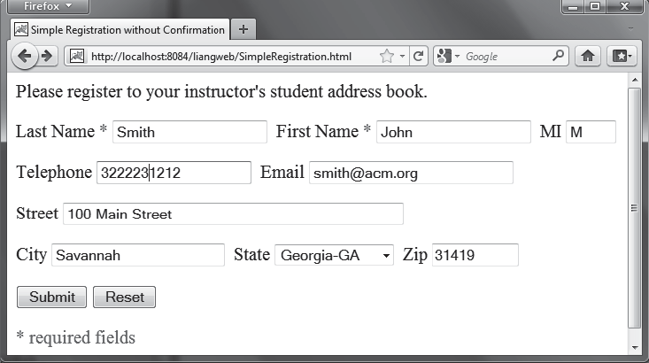
FIGuRE 37.19 The HTML form enables the user to enter student information.
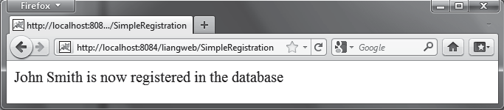
FIGuRE 37.20 The servlet processes the form and stores data in a database.



37-22 Chapter 37 Servlets
The registration data are stored in an Address table consisting of the following fields: firstName, mi, lastName, street, city, state, zip, telephone, and email, defined in the following statement:
create table Address ( firstname varchar(25), mi char(1),
lastname varchar(25), street varchar(40), city varchar(20), state varchar(2),
zip varchar(5), telephone varchar(10), email varchar(30)
)
MySQL, Oracle, and Access were used in Chapter 34. You can use any relational database. If the servlet uses a database driver other than the JDBC-ODBC driver (e.g., the MySQL JDBC driver and the Oracle JDBC driver), you need to add the JDBC driver (e.g., mysqljdbc.jar for MySQL and ojdbc6.jar for Oracle) into the Libraries node in the project.
Create an HTML file named SimpleRegistration.html in Listing 37.6 for collecting the data and sending them to the database using the post method.
Listing 37.6 SimpleRegistration.html
- <!-- SimpleRegistration.html -->
- <html>
- <head>
- <title>Simple Registration without Confirmation</title>
- </head>
- <body>
- Please register to your instructor’s student address book. 8
- <form method = "post" action = "SimpleRegistration">
- <p>Last Name <font color = "#FF0000">*</font>
- <input type = "text" name = "lastName">&nbsp;
- First Name <font color = "#FF0000">*</font>
- <input type = "text" name = "firstName">&nbsp;
- MI <input type = "text" name = "mi" size = "3">
15 </p>
- <p>Telephone
- <input type = "text" name = "telephone" size = "20">&nbsp;
- Email
- <input type = "text" name = "email" size = "28">&nbsp;
20 </p>
- <p>Street <input type = "text" name = "street" size = "50">
- </p>
- <p>City <input type = "text" name = "city" size = "23">&nbsp;
- State
- <select size = "1" name = "state">
- <option value = "GA">Georgia-GA</option>
- <option value = "OK">Oklahoma-OK</option>
- <option value = "IN">Indiana-IN</option>
- </select>&nbsp;
- Zip <input type = "text" name = "zip" size = "9">
31 </p>
- <p><input type = "submit" name = "Submit" value = "Submit">
- <input type = "reset" value = "Reset">
34 </p>
- </form>




Database Programming in Servlets 37-23

- <p><font color = "#FF0000">* required fields</font></p>
- </body>
- </html>
Create the servlet named SimpleRegistration in Listing 37.7.
Listing 37.7 SimpleRegistration.java
- package chapter37;
2
- import javax.servlet.*;
- import javax.servlet.http.*;
- import java.io.*;
- import java.sql.*;
7
- public class SimpleRegistration extends HttpServlet {
- // Use a prepared statement to store a student into the database
- private PreparedStatement pstmt; 11
- /** Initialize variables */
- public void init() throws ServletException {
- initializeJdbc();
15 }
16
- /** Process the HTTP Post request */
- public void doPost(HttpServletRequest request, HttpServletResponse
- response) throws ServletException, IOException {
- response.setContentType("text/html");
- PrintWriter out = response.getWriter(); 22
- // Obtain parameters from the client
- String lastName = request.getParameter("lastName");
- String firstName = request.getParameter("firstName");
- String mi = request.getParameter("mi");
- String phone = request.getParameter("telephone");
- String email = request.getParameter("email");
- String address = request.getParameter("street");
- String city = request.getParameter("city");
- String state = request.getParameter("state");
- String zip = request.getParameter("zip"); 33
- try {
- if (lastName.length() == 0 || firstName.length() == 0) {
- out.println("Last Name and First Name are required");
37 }
- else {
- storeStudent(lastName, firstName, mi, phone, email,
- address, city, state, zip); 41
- out.println(firstName + " " + lastName +
- " is now registered in the database");
44 }
45 }
- catch(Exception ex) {
- out.println("Error: " + ex.getMessage());
48 }
- finally {
- out.close(); // Close stream
51 }
52 }
53

37-24 Chapter 37 Servlets


54 |  | /** Initialize database connection */
55 |  | private void initializeJdbc() {
56 |  | try {
57 |  | // Load the JDBC driver
58 |  | Class.forName("com.mysql.jdbc.Driver");
59 |  | System.out.println("Driver loaded");
60
61 |  | // Establish a connection
62 |  | Connection conn = DriverManager.getConnection
63 |  | ("jdbc:mysql://localhost/javabook", "scott", "tiger");
64 |  | System.out.println("Database connected");
65
66 |  | // Create a Statement
67 |  | pstmt = conn.prepareStatement("insert into Address " +
68 |  | "(lastName, firstName, mi, telephone, email, street, city, "
69 |  | + "state, zip) values (?, ?, ?, ?, ?, ?, ?, ?, ?)");
70 |  | }
71 |  | catch (Exception ex) {
72 |  | ex.printStackTrace();
73 |  | }
74 |  | }
75
76 |  | /** Store a student record to the database */
77 |  | private void storeStudent(String lastName, String firstName,
78 |  | String mi, String phone, String email, String address,
79 |  | String city, String state, String zip) throws SQLException {
80 |  | pstmt.setString(1, lastName);
81 |  | pstmt.setString(2, firstName);
82 |  | pstmt.setString(3, mi);
83 |  | pstmt.setString(4, phone);
84 |  | pstmt.setString(5, email);
85 |  | pstmt.setString(6, address);
86 |  | pstmt.setString(7, city);
87 |  | pstmt.setString(8, state);
88 |  | pstmt.setString(9, zip);
89 |  | pstmt.executeUpdate();
90 |  | }
91 | }



Check Point
The init method (line 13) is executed once when the servlet starts. After the servlet has started, the servlet can be invoked many times as long as it is alive in the servlet container. Load the driver and connect to the database from the servlet’s init method (line 14). If a prepared statement or a callable statement is used, it should also be created in the init method. In this example, a prepared statement is desirable, because the servlet always uses the same insert statement with different values.
A servlet can connect to any relational database via JDBC. The initializeJdbc method in this example connects to a MySQL database (line 58). Once connected, it creates a prepared statement for inserting a student record into the database. MySQL is used in this example; you can replace it with any relational database.
Last name and first name are required fields. If either of them is empty, the servlet sends an error message to the client (lines 35–36). Otherwise, the servlet stores the data in the database using the prepared statement.
    - What would be displayed if you changed the content type to html/plain in Listing 37.2, CurrentTime.java?
    - The statement out.close() is used to close the output stream to response. Why isn’t this statement enclosed in a try-catch block?



  - Session Tracking 37-25
    - What happens when you invoke request.getParameter(paramName) if
paramName does not exist?
    - How do you write a text field, combo box, check box, and text area in an HTML form?
    - How do you retrieve the parameter value for a text field, combo box, list, check box, radio button, and text area from an HTML form?
    - If the servlet uses a database driver other than the JDBC-ODBC driver, where should the driver be placed in NetBeans?

Session Tracking

Key Point
You can perform session tracking using hidden values in a form, using cookies, or using HttpSession.
Web servers use the Hyper-Text Transport Protocol (HTTP). HTTP is a stateless protocol. An HTTP Web server cannot associate requests from a client, and therefore treats each request independently. This protocol works fine for simple Web browsing, where each request typi- cally results in an HTML file or a text file being sent back to the client. Such simple requests are isolated. However, the requests in interactive Web applications are often related. Consider the two requests in the following scenario:
Request 1: A client sends registration data to the server; the server then returns the data to the user for confirmation.
Request 2: The client confirms the data that was submitted in Request 1.
In Request 2, the data submitted in Request 1 are confirmed. These two requests are related in a session. A session can be defined as a series of related interactions between a single client and the Web server over a period of time. Tracking data among requests in a session is known as session tracking.
This section introduces three techniques for session tracking: using hidden values, using cookies, and using the session tracking tools from servlet API.

Session Tracking Using Hidden Values
You can track a session by passing data from the servlet to the client as hidden values in a dynamically generated HTML form by including a field like this one:

<input type = "hidden" name = "lastName" value = "Smith">

The next request will submit the data back to the servlet. The servlet retrieves this hidden value just like any other parameter value, using the getParameter method.
Let us use an example to demonstrate using hidden values in a form. The example creates a servlet that processes a registration form. The client submits the form using the GET method, as shown in Figure 37.21. The server collects the data in the form, displays them to the client, and asks the client for confirmation, as shown in Figure 37.22. The client confirms the data by submitting the request with the hidden values using the POST method. Finally, the servlet writes the data to a database.
Create an HTML form named Registration.html in Listing 37.8 for collecting the data and sending it to the database using the GET method for confirmation. This file is almost identical to Listing 37.6, SimpleRegistration.html except that the action is replaced by Registra- tion (line 9).


37-26 Chapter 37 Servlets
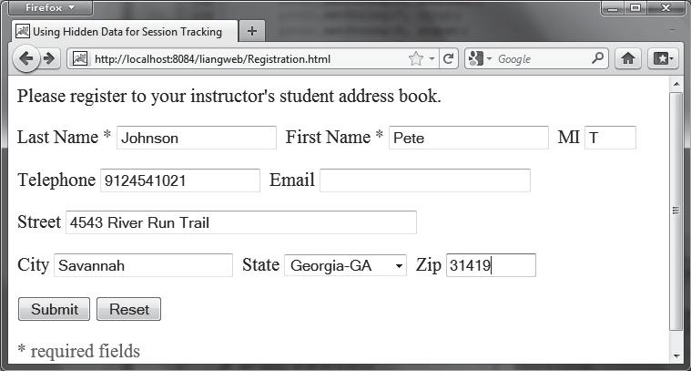
FIGuRE 37.21 The registration form collects user information.

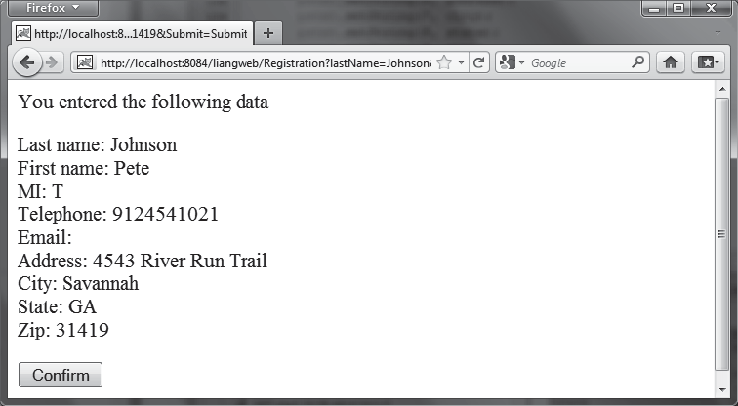
FIGuRE 37.22 The servlet asks the client for confirmation of the input.

Listing 37.8 Registration.html
- <!-- Registration.html -->
- <html>
- <head>
- <title>Using Hidden Data for Session Tracking</title>
- </head>
- <body>
- Please register to your instructor’s student address book. 8
- <form method = "get" action = "Registration">
- <p>Last Name <font color = "#FF0000">*</font>
- <input type = "text" name = "lastName"> &nbsp;
- First Name <font color = "#FF0000">*</font>
- <input type = "text" name = "firstName"> &nbsp;
- MI <input type = "text" name = "mi" size = "3">
15 </p>
- <p>Telephone
- <input type = "text" name = "telephone" size = "20"> &nbsp;
- Email




37.8 Session Tracking 37-27

- <input type = "text" name = "email" size = "28"> &nbsp;
20 </p>
- <p>Street <input type = "text" name = "street" size = "50">
- </p>
- <p>City <input type = "text" name = "city" size = "23"> &nbsp;
- State
- <select size = "1" name = "state">
- <option value = "GA">Georgia-GA</option>
- <option value = "OK">Oklahoma-OK</option>
- <option value = "IN">Indiana-IN</option>
- </select> &nbsp;
- Zip <input type = "text" name = "zip" size = "9">
31 </p>
- <p><input type = "submit" name = "Submit" value = "Submit">
- <input type = "reset" value = "Reset">
34 </p>
- </form>
- <p><font color = "#FF0000">* required fields</font></p>
- </body>
- </html>
Create the servlet named Registration in Listing 37.9.

Listing 37.9 Registration.java
1 package chapter37;
2
- import javax.servlet.*;
- import javax.servlet.http.*;
- import java.io.*;
- import java.sql.*;
7
- public class Registration extends HttpServlet {
- // Use a prepared statement to store a student into the database
- private PreparedStatement pstmt; 11
- /** Initialize variables */
- public void init() throws ServletException {
- initializeJdbc();
15 }
16
- /** Process the HTTP Get request */
- public void doGet(HttpServletRequest request, HttpServletResponse
- response) throws ServletException, IOException {
- response.setContentType("text/html");
- PrintWriter out = response.getWriter(); 22
- // Obtain data from the form
- String lastName = request.getParameter("lastName");
- String firstName = request.getParameter("firstName");
- String mi = request.getParameter("mi");
- String telephone = request.getParameter("telephone");
- String email = request.getParameter("email");
- String street = request.getParameter("street");
- String city = request.getParameter("city");
- String state = request.getParameter("state");
- String zip = request.getParameter("zip"); 33
- if (lastName.length() == 0 || firstName.length() == 0) {
- out.println("Last Name and First Name are required");
36 }



37-28 Chapter 37 Servlets

- else {
- // Ask for confirmation
- out.println("You entered the following data");
- out.println("<p>Last name: " + lastName);
- out.println("<br>First name: " + firstName);
- out.println("<br>MI: " + mi);
- out.println("<br>Telephone: " + telephone);
- out.println("<br>Email: " + email);
- out.println("<br>Address: " + street);
- out.println("<br>City: " + city);
- out.println("<br>State: " + state);
- out.println("<br>Zip: " + zip); 49
- // Set the action for processing the answers
- out.println("<p><form method=\"post\" action=" +
- "Registration>");
- // Set hidden values
- out.println("<p><input type=\"hidden\" " +
- "value=" + lastName + " name=\"lastName\">");
- out.println("<p><input type=\"hidden\" " +
- "value=" + firstName + " name=\"firstName\">");
- out.println("<p><input type=\"hidden\" " +
59 "value=" + mi + " name=\"mi\">");
- out.println("<p><input type=\"hidden\" " +
- "value=" + telephone + " name=\"telephone\">");
- out.println("<p><input type=\"hidden\" " +
- "value=" + email + " name=\"email\">");
- out.println("<p><input type=\"hidden\" " +
- "value=" + street + " name=\"street\">");
- out.println("<p><input type=\"hidden\" " +
- "value=" + city + " name=\"city\">");
- out.println("<p><input type=\"hidden\" " +
- "value=" + state + " name=\"state\">");
- out.println("<p><input type=\"hidden\" " +
- "value=" + zip + " name=\"zip\">");
- out.println("<p><input type=\"submit\" value=\"Confirm\" >");
- out.println("</form>");
74 }
75
76 out.close(); // Close stream
77 }
78
- /** Process the HTTP Post request */
- public void doPost(HttpServletRequest request, HttpServletResponse
- response) throws ServletException, IOException {
- response.setContentType("text/html");
- PrintWriter out = response.getWriter(); 84
- try {
- String lastName = request.getParameter("lastName");
- String firstName = request.getParameter("firstName");
- String mi = request.getParameter("mi");
- String telephone = request.getParameter("telephone");
- String email = request.getParameter("email");
- String street = request.getParameter("street");
- String city = request.getParameter("city");
- String state = request.getParameter("state");
- String zip = request.getParameter("zip"); 95
- storeStudent(lastName, firstName, mi, telephone, email,
- street, city, state, zip);




37.8 Session Tracking 37-29

98
- out.println(firstName + " " + lastName +
- " is now registered in the database");
101 }
- catch(Exception ex) {
- out.println("Error: " + ex.getMessage());
104 }
105 }
106
- /** Initialize database connection */
- private void initializeJdbc() {
- try {
- // Load the JDBC driver
- Class.forName("com.mysql.jdbc.Driver");
- System.out.println("Driver loaded");
113
- // Establish a connection
- Connection conn = DriverManager.getConnection
- ("jdbc:mysql://localhost/javabook" , "scott", "tiger");
- System.out.println("Database connected");
118
- // Create a Statement
- pstmt = conn.prepareStatement("insert into Address " +
- "(lastName, firstName, mi, telephone, email, street, city, "
122 + "state, zip) values (?, ?, ?, ?, ?, ?, ?, ?, ?)");
123 }
- catch (Exception ex) {
- System.out.println(ex);
126 }
127 }
128
- /** Store a student record to the database */
- private void storeStudent(String lastName, String firstName,
- String mi, String phone, String email, String address,
- String city, String state, String zip) throws SQLException {
- pstmt.setString(1, lastName);
- pstmt.setString(2, firstName);
- pstmt.setString(3, mi);
- pstmt.setString(4, phone);
- pstmt.setString(5, email);
- pstmt.setString(6, address);
- pstmt.setString(7, city);
- pstmt.setString(8, state);
- pstmt.setString(9, zip);
- pstmt.executeUpdate();
143 }
144 }

The servlet processes the GET request by generating an HTML page that displays the client’s input and asks for the client’s confirmation. The input data consist of hidden values in the newly generated forms, so they will be sent back in the confirmation request. The confirmation request uses the POST method. The servlet retrieves the hidden values and stores them in the database. Since the first request does not write anything to the database, it is appropriate to use the GET method. Since the second request results in an update to the database, the POST method
must be used.


Note
The hidden values could also be sent from the URL query string if the request used the GET method.


37-30 Chapter 37 Servlets

Session Tracking Using Cookies
You can track sessions using cookies, which are small text files that store sets of name/value pairs on the disk in the client’s computer. Cookies are sent from the server through the instruc- tions in the header of the HTTP response. The instructions tell the browser to create a cookie with a given name and its associated value. If the browser already has a cookie with the key name, the value will be updated. The browser will then send the cookie with any request submitted to the same server. Cookies can have expiration dates set, after which they will not be sent to the server. The javax.servlet.http.Cookie is used to create and manipulate cookies, as shown in Figure 37.23.


+getSecure(): boolean
+setSecure(flag: boolean): void

+getComment(): String

+setComment(purpose: String): void
+Cookie(name: String, value: String)
+getName(): String
+getValue(): String
+setValue(newValue: String): void
+getMaxAge(): int
+setMaxAge(expiration: int): void
javax.servlet.http.Cookie
Creates a cookie with the specified name-value pair. Returns the name of the cookie.
Returns the value of the cookie.
Assigns a new value to a cookie after the cookie is created. Returns the maximum age of the cookie, specified in seconds.
Specifies the maximum age of the cookie. By default, this value is –1, which implies that the cookie persists until the browser exits. If you set this value to 0, the cookie is deleted.

Returns true if the browser is sending cookies only over a secure protocol.
Indicates to the browser whether the cookie should only be sent using a secure protocol, such as HTTPS or SSL.

Returns the comment describing the purpose of this cookie, or null if the cookie has no comment.
Sets the comment for this cookie.
FIGuRE 37.23 Cookie stores a name/value pair and other information about the cookie.

To send a cookie to the browser, use the addCookie method in the HttpServlet- Response class, as shown below:
response.addCookie(cookie);

where response is an instance of HttpServletResponse. To obtain cookies from a browser, use

request.getCookies();

where request is an instance of HttpServletRequest.
To demonstrate the use of cookies, let us create an example that accomplishes the same task as Listing 37.9, Registration.java. Instead of using hidden values for session tracking, it uses cookies.
Create the servlet named RegistrationWithCookie in Listing 37.10. Create an HTML file named RegistrationWithCookie.html that is identical to Registration.html except that the action is replaced by RegistrationWithCookie.java.
Listing 37.10 RegistrationWithCookie.java
1 package chapter37;
2
- import javax.servlet.*;
- import javax.servlet.http.*;
- import java.io.*;




37.8 Session Tracking 37-31

- import java.sql.*;
7
- public class RegistrationWithCookie extends HttpServlet {
- private static final String CONTENT_TYPE = "text/html";
- // Use a prepared statement to store a student into the database
- private PreparedStatement pstmt; 12
- /** Initialize variables */
- public void init() throws ServletException {
- initializeJdbc();
16 }
17
- /** Process the HTTP Get request */
- public void doGet(HttpServletRequest request, HttpServletResponse
- response) throws ServletException, IOException {
- response.setContentType("text/html");
- PrintWriter out = response.getWriter(); 23
- // Obtain data from the form
- String lastName = request.getParameter("lastName");
- String firstName = request.getParameter("firstName");
- String mi = request.getParameter("mi");
- String telephone = request.getParameter("telephone");
- String email = request.getParameter("email");
- String street = request.getParameter("street");
- String city = request.getParameter("city");
- String state = request.getParameter("state");
- String zip = request.getParameter("zip"); 34
- if (lastName.length() == 0 || firstName.length() == 0) {
- out.println("Last Name and First Name are required");
37 }
- else {
- // Create cookies and send cookies to browsers
- Cookie cookieLastName = new Cookie("lastName", lastName);
- // cookieLastName.setMaxAge(1000);
- response.addCookie(cookieLastName);
- Cookie cookieFirstName = new Cookie("firstName", firstName);
- response.addCookie(cookieFirstName);
- // cookieFirstName.setMaxAge(0);
- Cookie cookieMi = new Cookie("mi", mi);
- response.addCookie(cookieMi);
- Cookie cookieTelephone = new Cookie("telephone", telephone);
- response.addCookie(cookieTelephone);
- Cookie cookieEmail = new Cookie("email", email);
- response.addCookie(cookieEmail);
- Cookie cookieStreet = new Cookie("street", street);
- response.addCookie(cookieStreet);
- Cookie cookieCity = new Cookie("city", city);
- response.addCookie(cookieCity);
- Cookie cookieState = new Cookie("state", state);
- response.addCookie(cookieState);
- Cookie cookieZip = new Cookie("zip", zip);
- response.addCookie(cookieZip);
60
- // Ask for confirmation
- out.println("You entered the following data");
- out.println("<p>Last name: " + lastName);
- out.println("<br>First name: " + firstName);
- out.println("<br>MI: " + mi);
- out.println("<br>Telephone: " + telephone);



37-32 Chapter 37 Servlets

- out.println("<br>Email: " + email);
- out.println("<br>Street: " + street);
- out.println("<br>City: " + city);
- out.println("<br>State: " + state);
- out.println("<br>Zip: " + zip); 72
- // Set the action for processing the answers
- out.println("<p><form method=\"post\" action=" +
- "RegistrationWithCookie>");
- out.println("<p><input type=\"submit\" value=\"Confirm\" >");
- out.println("</form>");
78 }
79
80 out.close(); // Close stream
81 }
82
- /** Process the HTTP Post request */
- public void doPost(HttpServletRequest request, HttpServletResponse
- response) throws ServletException, IOException {
- response.setContentType(CONTENT_TYPE);
- PrintWriter out = response.getWriter(); 88
- String lastName = "";
- String firstName = "";
- String mi = "";
- String telephone = "";
- String email = "";
- String street = "";
- String city = "";
- String state = "";
- String zip = ""; 98
- // Read the cookies
- Cookie[] cookies = request.getCookies(); 101
- // Get cookie values
- for (int i = 0; i < cookies.length; i++) {
- if (cookies[i].getName().equals("lastName"))
- lastName = cookies[i].getValue();
- else if (cookies[i].getName().equals("firstName"))
- firstName = cookies[i].getValue();
- else if (cookies[i].getName().equals("mi"))
- mi = cookies[i].getValue();
- else if (cookies[i].getName().equals("telephone"))
- telephone = cookies[i].getValue();
- else if (cookies[i].getName().equals("email"))
- email = cookies[i].getValue();
- else if (cookies[i].getName().equals("street"))
- street = cookies[i].getValue();
- else if (cookies[i].getName().equals("city"))
- city = cookies[i].getValue();
- else if (cookies[i].getName().equals("state"))
- state = cookies[i].getValue();
- else if (cookies[i].getName().equals("zip"))
- zip = cookies[i].getValue();
122 }
123
124 try {
storeStudent(lastName, firstName, mi, telephone, email, street,
125
126 city, state, zip); 127




 |  |  |  |  | 37.8 | Session Tracking 37-33
128 |  |  | out.println(firstName | + " " + lastName +
129 |  |  | " is now registered | in the database");
130
131 |  |  | out.close(); // Close | stream
132 |  |  | }
133 |  |  | catch(Exception ex) {
134 |  |  | out.println("Error: " | + ex.getMessage());
135 |  |  | }
136 |  | }
137
138 |  | /** Initialize database connection */
139 |  | private void initializeJdbc() {
140 |  | try {
141 |  | // Load the JDBC driver
142 |  | Class.forName("com.mysql.jdbc.Driver");
143 |  | System.out.println("Driver loaded");
144
145 |  | // Establish a connection
146 |  | Connection conn = DriverManager.getConnection
147 |  | ("jdbc:mysql://localhost/javabook" , "scott", "tiger");
148 |  | System.out.println("Database connected");
149
150 |  | // Create a Statement
151 |  | pstmt = conn.prepareStatement("insert into Address " +
152 |  | "(lastName, firstName, mi, telephone, email, street, city, |  |  |  | "
153 |  | + "state, zip) values (?, ?, ?, ?, ?, ?, ?, ?, ?)");
154 |  | }
155 |  | catch (Exception ex) {
156 |  | System.out.println(ex);
157 |  | }
158 |  | }
159
160 |  | /** Store a student record to the database */
161 |  | private void storeStudent(String lastName, String firstName,
162 |  | String mi, String telephone, String email, String street,
163 |  | String city, String state, String zip) throws SQLException {
164 |  | pstmt.setString(1, lastName);
165 |  | pstmt.setString(2, firstName);
166 |  | pstmt.setString(3, mi);
167 |  | pstmt.setString(4, telephone);
168 |  | pstmt.setString(5, email);
169 |  | pstmt.setString(6, street);
170 |  | pstmt.setString(7, city);
171 |  | pstmt.setString(8, state);
172 |  | pstmt.setString(9, zip);
173 |  | pstmt.executeUpdate();
174 |  | }
175 | }

You have to create a cookie for each value you want to track, using the Cookie class’s only constructor, which defines a cookie’s name and value as shown below (line 40):
Cookie cookieLastName = new Cookie("lastName", lastName);
To send the cookie to the browser, use a statement like this one (line 42):

response.addCookie(cookieLastName);

If a cookie with the same name already exists in the browser, its value is updated; otherwise, a new cookie is created.



37-34 Chapter 37 Servlets
Cookies are automatically sent to the Web server with each request from the client. The servlet retrieves all the cookies into an array using the getCookies method (line 100):
Cookie[] cookies = request.getCookies();

To obtain the name of the cookie, use the getName method (line 104):
String name = cookies[i].getName();

The cookie’s value can be obtained using the getValue method:
String value = cookies[i].getValue();

Cookies are stored as strings just like form parameters and hidden values. If a cookie represents a numeric value, you have to convert it into an integer or a double, using the parseInt method in the Integer class or the parseDouble method in the Double class.
By default, a newly created cookie persists until the browser exits. However, you can set an expiration date, using the setMaxAge method, to allow a cookie to stay in the browser for up to 2,147,483,647 seconds (approximately 24,855 days).

Session Tracking Using the Servlet API
You have now learned both session tracking using hidden values and session tracking using cookies. These two session-tracking methods have problems. They send data to the browser either as hidden values or as cookies. The data are not secure, and anybody with knowledge of computers can obtain them. The hidden data are in HTML form, which can be viewed from the browser. Cookies are stored in the Cache directory of the browser. Because of security concerns, some browsers do not accept cookies. The client can turn the cookies off and limit their number. Another problem is that hidden data and cookies pass data as strings. You cannot pass objects using these two methods.
To address these problems, Java servlet API provides the javax.servlet.http
.HttpSession interface, which provides a way to identify a user across more than one page request or visit to a website and to store information about that user. The servlet container uses this interface to create a session between an HTTP client and an HTTP server. The session persists for a specified time period, across more than one connection or page request from the user. A session usually corresponds to one user, who may visit a site many times. The session enables tracking of a large set of data. The data can be stored as objects and are secure because they are kept on the server side.
To use the Java servlet API for session tracking, first create a session object using the
getSession() method in the HttpServletRequest interface:
HttpSession session = request.getSession();

This obtains the session or creates a new session if the client does not have a session on the server.
The HttpSession interface provides the methods for reading and storing data to the session, and for manipulating the session, as shown in Figure 37.24.


Note
HTTP is stateless. So how does the server associate a session with multiple requests from the same client? This is handled behind the scenes by the servlet container and is transparent to the servlet programmer.

To demonstrate using HttpSession, let us rewrite Listing 37.9, Registration.java, and List- ing 37.10, RegistrationWithCookie.java. Instead of using hidden values or cookies for session tracking, it uses servlet HttpSession.



37.8 Session Tracking 37-35


+getMaxInactiveInterval(): int
+setMaxInactiveInterval(interval: int): void
+invalidate(): void
+isNew(): boolean
+removeAttribute(name: String): void
+getLastAccessedTime(): long
+getAttribute(name: String): Object

+setAttribute(name: String, value: Object): void

+getId(): String
<<interface>>
javax.servlet.http.HttpSession
Returns the object bound with the specified name in this session, or null if no object is bound under the name.
Binds an object to this session, using the specified name. If an object of the same name is already bound to the session, the object is replaced.
Returns a string containing the unique identifier assigned to this session. The identifier is assigned by the servlet container and is implementation dependent.
Returns the last time the client sent a request associated with this session, as the number of milliseconds since midnight January 1, 1970 GMT, and marked by the time the container received the request.
Invalidates this session, then unbinds any objects bound to it. Returns true if the session was just created in the current request. Removes the object bound with the specified name from this ses-
sion. If the session does not have an object bound with the
specified name, this method does nothing.

Returns the time, in seconds, between client requests before the servlet container will invalidate this session. A negative time indicates that the session will never time-out. Use setMaxInac- tiveInterval to specify this value.
FIGuRE 37.24 HttpSession establishes a persistent session between a client with multiple requests and the server.

Create the servlet named RegistrationWithHttpSession in Listing 37.11. Create an HTML file named RegistrationWithHttpSession.html that is identical to Regis- tration.html except that the action is replaced by RegistrationWithHttpSession.

Listing 37.11 RegistrationWithHttpSession.java
1 package chapter37;
2
- import javax.servlet.*;
- import javax.servlet.http.*;
- import java.io.*;
- import java.sql.*;
7
- public class RegistrationWithHttpSession extends HttpServlet {
- // Use a prepared statement to store a student into the database
- private PreparedStatement pstmt; 11
- /** Initialize variables */
- public void init() throws ServletException {
- initializeJdbc();
15 }
16
- /** Process the HTTP Get request */
- public void doGet(HttpServletRequest request, HttpServletResponse
- response) throws ServletException, IOException {



37-36 Chapter 37 Servlets

- // Set response type and output stream to the browser
- response.setContentType("text/html");
- PrintWriter out = response.getWriter(); 23
- // Obtain data from the form
- String lastName = request.getParameter("lastName");
- String firstName = request.getParameter("firstName");
- String mi = request.getParameter("mi");
- String telephone = request.getParameter("telephone");
- String email = request.getParameter("email");
- String street = request.getParameter("street");
- String city = request.getParameter("city");
- String state = request.getParameter("state");
- String zip = request.getParameter("zip"); 34
- if (lastName.length() == 0 || firstName.length() == 0) {
- out.println("Last Name and First Name are required");
37 }
- else {
- // Create an Address object
- Address address = new Address();
- address.setLastName(lastName);
- address.setFirstName(firstName);
- address.setMi(mi);
- address.setTelephone(telephone);
- address.setEmail(email);
- address.setStreet(street);
- address.setCity(city);
- address.setState(state);
- address.setZip(zip);
50
- // Get an HttpSession or create one if it does not exist
- HttpSession httpSession = request.getSession(); 53
- // Store student object to the session
- httpSession.setAttribute("address", address);
56
- // Ask for confirmation
- out.println("You entered the following data");
- out.println("<p>Last name: " + lastName);
- out.println("<p>First name: " + firstName);
- out.println("<p>MI: " + mi);
- out.println("<p>Telephone: " + telephone);
- out.println("<p>Email: " + email);
- out.println("<p>Address: " + street);
- out.println("<p>City: " + city);
- out.println("<p>State: " + state);
- out.println("<p>Zip: " + zip); 68
- // Set the action for processing the answers
- out.println("<p><form method=\"post\" action=" +
- "RegistrationWithHttpSession>");
- out.println("<p><input type=\"submit\" value=\"Confirm\" >");
- out.println("</form>");
74 }
75
76 out.close(); // Close stream
77 }
78
79 /** Process the HTTP Post request */



  - Session Tracking 37-37

80 public void doPost(HttpServletRequest request, HttpServletResponse
81 response) throws ServletException, IOException {
82 |  | // Set response type and output stream to the browser
83 |  | response.setContentType("text/html");
84 |  | PrintWriter out = response.getWriter();
85
86 |  | // Obtain the HttpSession
87 |  | HttpSession httpSession = request.getSession();
88
89 |  | // Get the Address object in the HttpSession
90 |  | Address address = (Address)(httpSession.getAttribute("address"));
91
92 |  | try {
93 |  | storeStudent(address);
95 |  | out.println(address.getFirstName() + " " + address.getLastName()
96 |  | + " is now registered in the database");
97 |  | out.close(); // Close stream
98 |  | }
99 |  | catch(Exception ex) {
100 |  | out.println("Error: " + ex.getMessage());
101 |  | }
102 |  | }
103
104 |  | /** Initialize database connection */
105 |  | private void initializeJdbc() {
106 |  | try {
107 |  | // Load the JDBC driver
108 |  | Class.forName("com.mysql.jdbc.Driver");
109 |  | System.out.println("Driver loaded");
110
111 |  | // Establish a connection
112 |  | Connection conn = DriverManager.getConnection
113 |  | ("jdbc:mysql://localhost/javabook" , "scott", "tiger");
114 |  | System.out.println("Database connected");
115
116 |  | // Create a Statement
117 |  | pstmt = conn.prepareStatement("insert into Address " +
118 |  | "(lastName, firstName, mi, telephone, email, street, city, "
119 |  | + "state, zip) values (?, ?, ?, ?, ?, ?, ?, ?, ?)");
120 |  | }
121 |  | catch (Exception ex) {
122 |  | System.out.println(ex);
123 |  | }
124 |  | }
125
126 |  | /** Store an address to the database */
127 |  | private void storeStudent(Address address) throws SQLException {
128 |  | pstmt.setString(1, address.getLastName());
129 |  | pstmt.setString(2, address.getFirstName());
130 |  | pstmt.setString(3, address.getMi());
131 |  | pstmt.setString(4, address.getTelephone());
132 |  | pstmt.setString(5, address.getEmail());
133 |  | pstmt.setString(6, address.getStreet());
134 |  | pstmt.setString(7, address.getCity());
135 |  | pstmt.setString(8, address.getState());
136 |  | pstmt.setString(9, address.getZip());
137 |  | pstmt.executeUpdate();
138 |  | }
139 | }

94



37-38 Chapter 37 Servlets
The statement (line 52)
HttpSession httpSession = request.getSession();
obtains a session, or creates a new session if the session does not exist.
Since objects can be stored in HttpSession, this program defines an Address class. An Address object is created and is stored in the session using the setAttribute method, which binds the object with a name like the one shown below (line 55):
httpSession.setAttribute("address", address);
To retrieve the object, use the following statement (line 90):
Address address = (Address)(httpSession.getAttribute("address"));
There is only one session between a client and a servlet. You can store any number of objects in a session. By default, the maximum inactive interval on many Web servers including Tomcat and GlassFish is 1800 seconds (i.e., a half-hour), meaning that the session expires if there is no activity for 30 minutes. You can change the default using the setMaxInactiveInterval method. For example, to set the maximum inactive interval to one hour, use
httpSession.setMaxInactiveInterval(3600);
If you set a negative value, the session will never expire.
For this servlet program to work, you have to create the Address class in NetBeans, as follows:
- Choose New, Java Class from the context menu of the liangweb node in the project pane to display the New Java Class dialog box.
- Enter Address as the Class Name and chapter37 as the package name. Click Finish
to create the class.
- Enter the code, as shown in Listing 37.12.

Listing 37.12 Address.java
1 package chapter37;
2
- public class Address {
- private String firstName;
- private String mi;
- private String lastName;
- private String telephone;
- private String street;
- private String city;
- private String state;
- private String email;
- private String zip; 13
- public String getFirstName() {
- return this.firstName;
16 }
17
- public void setFirstName(String firstName) {
- this.firstName = firstName;
20 }
21
- public String getMi() {
- return this.mi;
24 }




37.8 Session Tracking 37-39

25
- public void setMi(String mi) {
- this.mi = mi;
28 }
29
- public String getLastName() {
- return this.lastName;
32 }
33
- public void setLastName(String lastName) {
- this.lastName = lastName;
36 }
37
- public String getTelephone() {
- return this.telephone;
40 }
41
- public void setTelephone(String telephone) {
- this.telephone = telephone;
44 }
45
- public String getEmail() {
- return this.email;
48 }
49
- public void setEmail(String email) {
- this.email = email;
52 }
53
- public String getStreet() {
- return this.street;
56 }
57
- public void setStreet(String street) {
- this.street = street;
60 }
61
- public String getCity() {
- return this.city;
64 }
65
- public void setCity(String city) {
- this.city = city;
68 }
69
- public String getState() {
- return this.state;
72 }
73
- public void setState(String state) {
- this.state = state;
76 }
77
- public String getZip() {
- return this.zip;
80 }
81
82 public void setZip(String zip) {
83 this.zip = zip;
84 }
85 }

37-40 Chapter 37 Servlets

Check Point
This support class will also be reused in the upcoming chapters.

    - What is session tracking? What are three techniques for session tracking?
    - How do you create a cookie, send a cookie to a browser, get cookies from a browser, get the name of a cookie, set a new value in the cookie, and set cookie expiration time?
    - Do you have to create five Cookie objects in the servlet in order to send five cookies to the browser?
    - How do you get a session, set object value for the session, and get object value from the session?
    - Suppose you inserted the following code in line 53 in Listing 37.11:
httpSession.setMaxInactiveInterval(1);
What would happen after the user clicked the Confirm button from the browser? Test your answer by running the program.
    - Suppose you inserted the following code in line 53 in Listing 37.11:
httpSession.setMaxInactiveInterval(-1);
What would happen after the user clicked the Confirm button from the browser?

KEy TERMS

Common Gateway Interface 37-3 CGI programs 37-3
cookie 37-30
GET and POST methods 37-3 GlassFish 37-5
HTML form 37-15
URL query string 37-3 servlet 37-2
servlet container (servlet engine) 37-4 servelt life-cycle methods 37-10 Tomcat 37-5




CHaPTER SuMMaRy
      - A servlet is a special kind of program that runs from a Web server. Tomcat and GlassFish are Web servers that can run servlets.

      - A servlet URL is specified by the host name, port, and request string (e.g., http:// localhost:8084/liangweb/ServletClass). There are several ways to invoke a servlet:
(1) by typing a servlet URL from a Web browser, (2) by placing a hyper link in an HTML page, and (3) by embedding a servlet URL in an HTML form. All the requests trigger the GET method, except that in the HTML form you can explicitly specify the POST method.

      - You develop a servlet by defining a class that extends the HttpServlet class, imple- ments the doGet(HttpServletRequest, HttpServletResponse) method to respond to the GET method, and implements the doPost(HttpServletRequest, HttpServletResponse) method to respond to the POST method.




Programming Exercises 37-41
      - The request information passed from a client to the servlet is contained in an object of HttpServletRequest. You can use the methods getParameter, getParam- eterValues, getRemoteAddr, getRemoteHost, getHeader, getQueryString, getCookies, and getSession to obtain the information from the request.

      - The content sent back to the client is contained in an object of HttpServletResponse. To send content to the client, first set the type of the content (e.g., html/plain) using the setContentType(contentType) method, then output the content through an I/O stream on the HttpServletResponse object. You can obtain a character PrintWriter stream using the getWriter() method and obtain a binary Output- Stream using the getOutputStream() method.
      - A servlet may be shared by many clients. When the servlet is first created, its init method is called. It is not called again as long as the servlet is not destroyed. The ser- vice method is invoked each time the server receives a request for the servlet. The server spawns a new thread and invokes service. The destroy method is invoked after a timeout period has passed or the Web server is stopped.

      - There are three ways to track a session. You can track a session by passing data from the servlet to the client as a hidden value in a dynamically generated HTML form by includ- ing a field such as <input type="hidden" name="lastName" value="Smith">. The next request will submit the data back to the servlet. The servlet retrieves this hidden value just like any other parameter value using the getParameter method.
      - You can track sessions using cookies. A cookie is created using the constructor new Cookie(String name, String value). Cookies are sent from the server through the object of HttpServletResponse using the addCookie(aCookie) method to tell the browser to add a cookie with a given name and its associated value. If the browser already has a cookie with the key name, the value will be updated. The browser will then send the cookie with any request submitted to the same server. Cookies can have expiration dates set, after which they will not be sent to the server.

      - Java servlet API provides a session-tracking tool that enables tracking of a large set of data. A session can be obtained using the getSession() method through an HttpServletRequest object. The data can be stored as objects and are secure because they are kept on the server side using the setAttribute(String name, Object value) method.

QuIZ
Answer the quiz for this chapter online at the book Companion Website.

PROgRaMMINg ExERCISES

Section 37.5
*37.1 (Factorial table) Write a servlet to display a table that contains factorials for the numbers from 0 to 10, as shown in Figure 37.25.



37-42 Chapter 37 Servlets
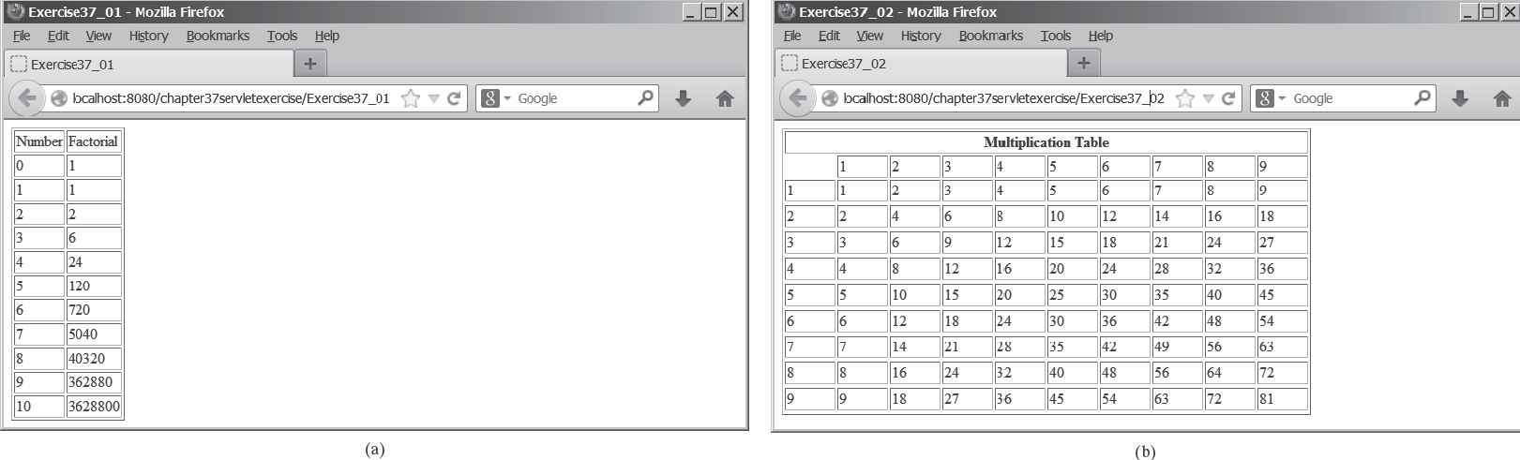
(a)
(b)
FIGuRE 37.25 (a) The servlet displays factorials for the numbers from 0 to 10 in a table. (b) The servlet displays the multiplication table.

*37.2 (Multiplication table) Write a servlet to display a multiplication table, as shown in Figure 37.25b.
*37.3 (Visit count) Develop a servlet that displays the number of visits on the servlet. Also display the client’s host name and IP address, as shown in Figure 37.26.

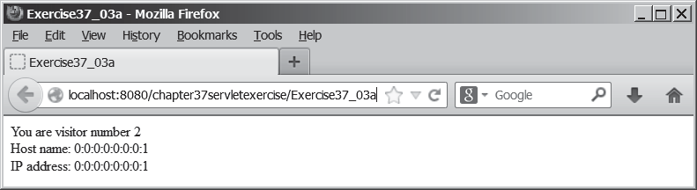
FIGuRE 37.26 The servlet displays the number of visits and the client’s host name, IP address, and request URL.

Implement this program in three different ways:
- Use an instance variable to store count. When the servlet is created for the first time, count is 0. count is incremented every time the servlet’s doGet method is invoked. When the Web server stops, count is lost.
- Store the count in a file named Exercise39_3.dat, and use RandomAccess- File to read the count in the servlet’s init method. The count is incremented every time the servlet’s doGet method is invoked. When the Web server stops, store the count back to the file.
- Instead of counting total visits from all clients, count the visits by each client identified by the client’s IP address. Use Map to store a pair of IP addresses and visit counts. For the first visit, an entry is created in the map. For subsequent visits, the visit count is updated.

Section 37.6
*37.4 (Calculate tax) Write an HTML form to prompt the user to enter taxable income and filing status, as shown in Figure 37.27a. Clicking the Compute Tax button invokes a servlet to compute and display the tax, as shown in Figure 37.27b. Use the computeTax method introduced in Listing 3.7, ComputingTax.java, to compute tax.



Programming Exercises 37-43
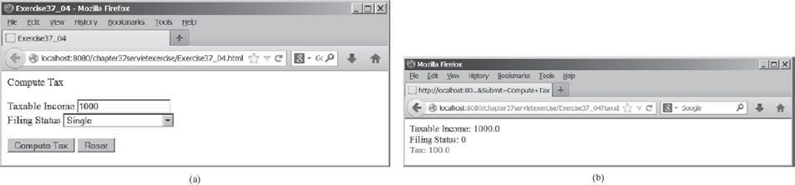
(a)
(b)
FIGuRE 37.27 The servlet computes the tax.

*37.5 (Calculate loan) Write an HTML form that prompts the user to enter loan amount, interest rate, and number of years, as shown in Figure 37.28a. Clicking the Compute Loan Payment button invokes a servlet to compute and display the monthly and total loan payments, as shown in Figure 37.28b. Use the Loan class given in Listing 10.2, Loan.java, to compute the monthly and total payments.

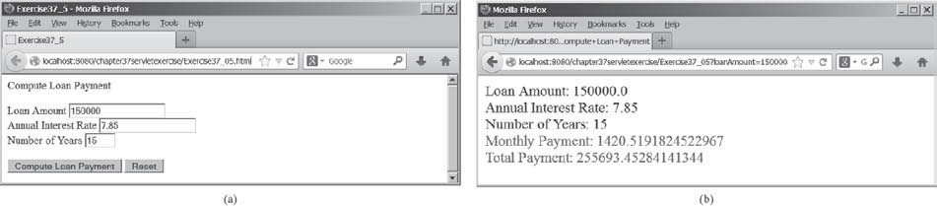
(a)
(b)
FIGuRE 37.28 The servlet computes the loan payment.

**37.6 (Find scores from text files) Write a servlet that displays the student name and the current score, given the SSN and class ID. For each class, a text file is used to store the student name, SSN, and current score. The file is named after the class ID with
.txt extension. For instance, if the class ID were csci1301, the file name would be csci1301.txt. Suppose each line consists of student name, SSN, and score. These three items are separated by the # sign. Create an HTML form that enables the user to enter the SSN and class ID, as shown in Figure 37.29a. Upon clicking the Submit button, the result is displayed, as shown in Figure 37.29b. If the SSN or the class ID does not match, report an error. Assume three courses are available: CSCI1301, CSCI1302, and CSCI3720.

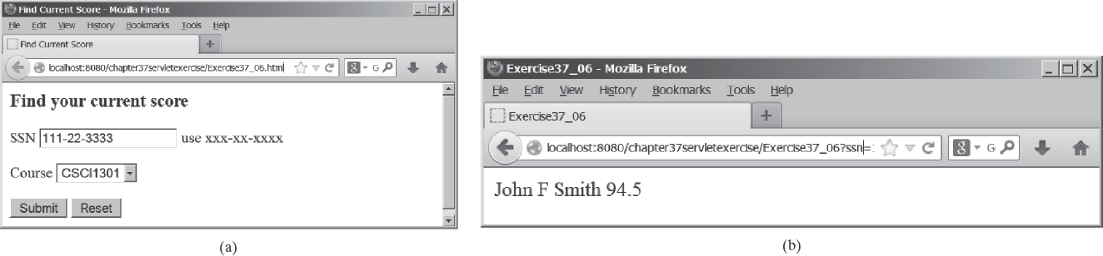
(a)
(b)
FIGuRE 37.29 The HTML form accepts the SSN and class ID from the user and sends them to the servlet to obtain the score.



37-44 Chapter 37 Servlets

Section 37.7
**37.7 (Find scores from database tables) Rewrite the preceding servlet. Assume for each class, a table is used to store the student name, ssn, and score. The table name is the same as the class ID. For instance, if the class ID were csci1301, the table name would be csci1301.
*37.8 (Change the password) Write a servlet that enables the user to change the password from an HTML form, as shown in Figure 37.30a. Suppose the user information is stored in a database table named Account with three columns: username, password, and name, where name is the real name of the user. The servlet performs the fol- lowing tasks:
- Verify that the username and old password are in the table. If not, report the error and redisplay the HTML form.
- Verify that the new password and the confirmed password are the same. If not, report this error and redisplay the HTML form.
- If the user information is entered correctly, update the password and report the status of the update to the user, as shown in Figure 37.30b.

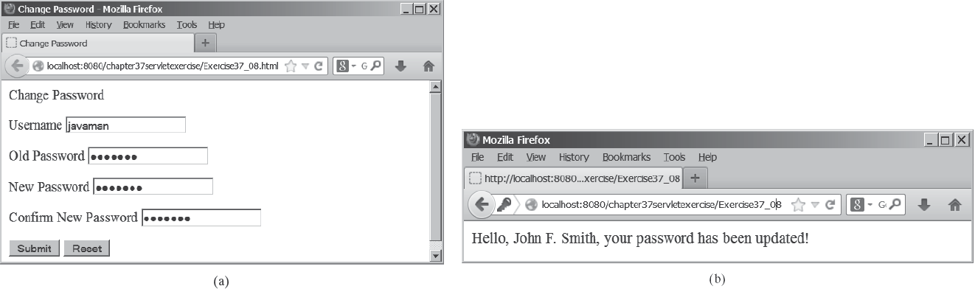
(a)
(b)
FIGuRE 37.30 The user enters the username and the old password and sets a new password. The servlet reports the status of the update to the user.

**37.9 (Display database tables) Write an HTML form that prompts the user to enter or select a JDBC driver, database URL, username, password, and table name, as shown in Figure 37.31a. Clicking the Submit button displays the table content, as shown in Figure 37.31b.

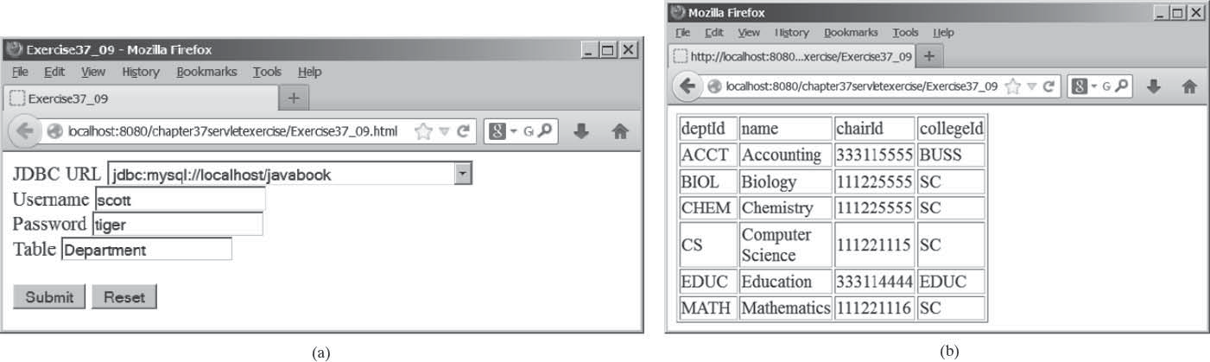
(a)
(b)
FIGuRE 37.31 The user enters database information and specifies a table to display its content.

Section 37.8
Programming Exercises 37-45


*37.10 (Store cookies) Write a servlet that stores the following cookies in a browser, and set their max age for two days.
Cookie 1: name is “color” and value is red. Cookie 2: name is “radius” and value is 5.5. Cookie 3: name is “count” and value is 2.
*37.11 (Retrieve cookies) Write a servlet that displays all the cookies on the client. The client types the URL of the servlet from the browser to display all the cookies stored on the browser. (see Figure 37.32.)

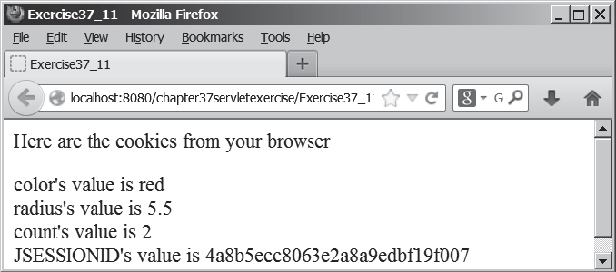
FIGuRE 37.32 All the cookies on the client are displayed in the browser.

Comprehensive
***37.12 (Syntax highlighting) Create an HTML form that prompts the user to enter a Java program in a text area, as shown in Figure 37.33a. The form invokes a servlet that displays the Java source code in a syntax-highlighted HTML format, as shown in Figure 37.33b. The keywords, comments, and literals are displayed in bold navy, green, and blue, respectively.

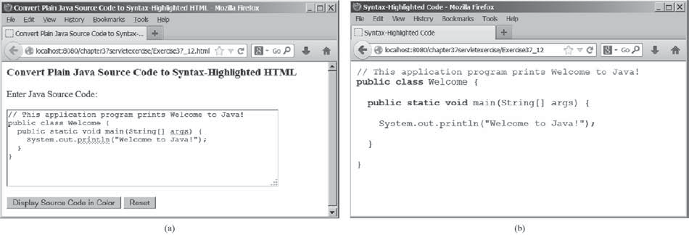
(a)
(b)
FIGuRE 37.33 The Java code in plain text in (a) is displayed in HTML with syntax highlighted in (b).




37-46 Chapter 37 Servlets
**37.13 (Access and update a Staff table) Write a Java servlet for Exercise 33.1, as shown in Figure 37.34.

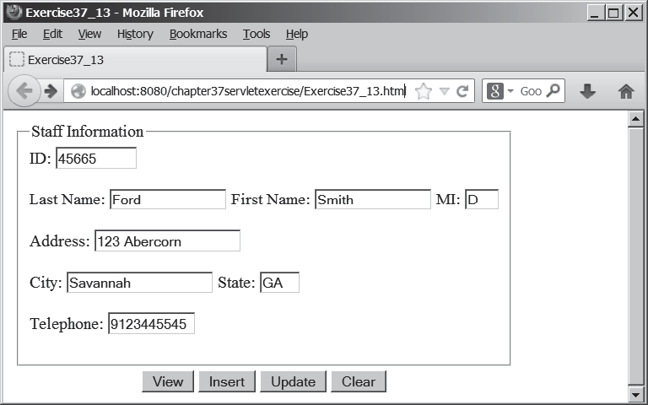
FIGuRE 37.34 The webpage lets you view, insert, and update staff information.

***37.14 (Opinion poll) Create an HTML form that prompts the user to answer a question such as “Are you a CS major?”, as shown in Figure 37.35a. When the Submit button is clicked, the servlet increases the Yes or No count in a database and displays the current Yes and No counts, as shown in Figure 37.35b.

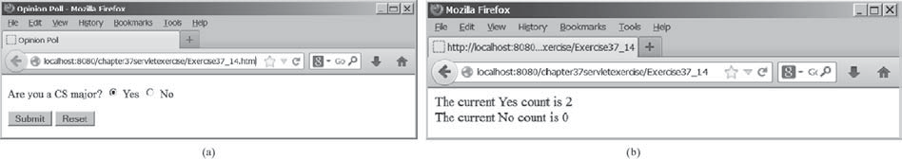
(a)
(b)
FIGuRE 37.35 The HTML form prompts the user to enter Yes or No for a question in (a), and the servlet updates the Yes or No counts (b).

Create a table named Poll, as follows:
create table Poll (
question varchar(40) primary key, yesCount int,
noCount int);

Insert one row into the table, as follows:

insert into Poll values ('Are you a CS major? ', 0, 0);

